**1. Create an application to design a Visiting Card. The Visiting card should have a company logo at the top right corner. The company name should be displayed in Capital letters, aligned to the center. Information like the name of the employee, job title, phone number, address, email, fax and the website address is to be displayed. Insert a horizontal line between the job title and the phone number.**

**SOURCE CODE**

**XML CODE - activity_main.xml**

<?xml version="1.0" encoding="utf-8"?>

<RelativeLayout xmlns:android="http://schemas.android.com/apk/res/android"

xmlns:app="http://schemas.android.com/apk/res-auto"

xmlns:tools="http://schemas.android.com/tools"

android:layout_width="match_parent"

android:layout_height="match_parent"

tools:context=".MainActivity">

<ImageView

android:id="@+id/imageView"

android:layout_width="93dp"

android:layout_height="129dp"

android:layout_alignParentEnd="true"

android:layout_marginEnd="290dp"

app:srcCompat="@android:drawable/btn_star_big_on" />

<TextView

android:id="@+id/TEXTName"

android:layout_width="wrap_content"

android:layout_height="wrap_content"

android:layout_alignParentEnd="true"

android:layout_alignParentBottom="true"

android:layout_marginEnd="208dp"

android:layout_marginBottom="450dp"

android:text="Name:Jwalish Joseph"

android:textColor="@color/black" />

<TextView

android:id="@+id/textRole"

android:layout_width="wrap_content"

android:layout_height="wrap_content"

android:layout_alignParentEnd="true"

android:layout_alignParentBottom="true"

android:layout_marginEnd="195dp"

android:layout_marginBottom="423dp"

android:text="Role: Software Engineer"

android:textColor="@color/black" />

<TextView

android:id="@+id/textLine"

android:layout_width="305dp"

android:layout_height="2dp"

android:layout_alignParentEnd="true"

android:layout_alignParentBottom="true"

android:layout_marginEnd="62dp"

android:layout_marginBottom="414dp"

android:background="@color/black"

android:gravity="center_horizontal"

android:textColor="@color/black" />

<TextView

android:id="@+id/textMobile"

android:layout_width="wrap_content"

android:layout_height="wrap_content"

android:layout_alignParentEnd="true"

android:layout_alignParentBottom="true"

android:layout_marginEnd="215dp"

android:layout_marginBottom="331dp"

android:text="Mobile: 8088101807"

android:textColor="@color/black" />

<TextView

android:id="@+id/textView3"

android:layout_width="wrap_content"

android:layout_height="wrap_content"

android:layout_alignParentEnd="true"

android:layout_alignParentBottom="true"

android:layout_marginEnd="98dp"

android:layout_marginBottom="384dp"

android:text="Address:Mundaje Post,Beltangady taluk"

android:textColor="@color/black" />

<TextView

android:id="@+id/textEmail"

android:layout_width="wrap_content"

android:layout_height="wrap_content"

android:layout_alignParentEnd="true"

android:layout_alignParentBottom="true"

android:layout_marginEnd="178dp"

android:layout_marginBottom="357dp"

android:text="E-mail:jwalishj@gmail.com"

android:textColor="@color/black" />

<TextView

android:id="@+id/textFax"

android:layout_width="wrap_content"

android:layout_height="wrap_content"

android:layout_alignParentEnd="true"

android:layout_alignParentBottom="true"

android:layout_marginLeft="50sp"

android:layout_marginTop="535sp"

android:layout_marginEnd="210dp"

android:layout_marginBottom="166dp"

android:text="Fax : 080-234549"

android:textColor="@color/black"

android:textSize="18sp" />

<TextView

android:id="@+id/textView2"

android:layout_width="wrap_content"

android:layout_height="wrap_content"

android:layout_alignParentEnd="true"

android:layout_alignParentBottom="true"

android:layout_marginEnd="181dp"

android:layout_marginBottom="304dp"

android:text="Website: www.Divine.com"

android:textColor="@color/black" />

<TextView

android:id="@+id/textView4"

android:layout_width="wrap_content"

android:layout_height="wrap_content"

android:layout_alignParentStart="true"

android:layout_alignParentTop="true"

android:layout_alignParentEnd="true"

android:layout_alignParentBottom="true"

android:layout_marginStart="191dp"

android:layout_marginTop="109dp"

android:layout_marginEnd="-28dp"

android:layout_marginBottom="560dp"

android:text="DIVINE ENTERPRICES"

android:textColor="@color/purple_500"

android:textSize="25dp"

android:textStyle="bold" />

</RelativeLayout>

**JAVA CODE - MainActivity.java**

package com.technicbvoc.applab1;

import androidx.appcompat.app.AppCompatActivity;

import android.os.Bundle;

public class MainActivity extends AppCompatActivity {

@Override

protected void onCreate(Bundle savedInstanceState) {

super.onCreate(savedInstanceState);

setContentView(R.layout.activity_visiting);

}

}

Output:

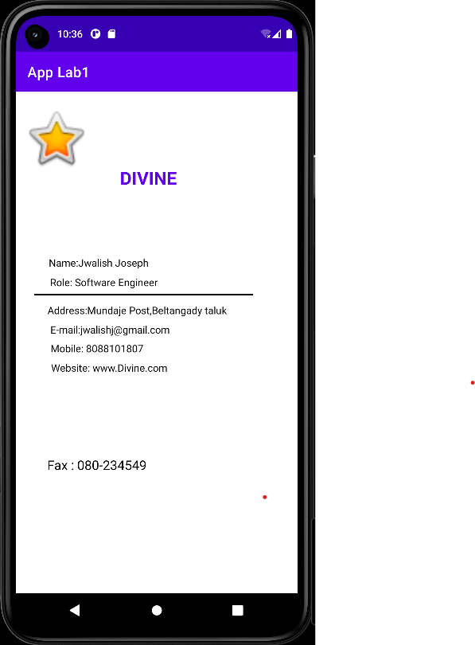

**2. Develop an Android application using controls like Button, TextView, and EditText for designing a calculator having basic functionality like Addition, Subtraction, Multiplication, and Division.**

**SOURCE CODE**

**XML CODE :**

<?xml version="1.0" encoding="utf-8"?>

<RelativeLayout xmlns:android="http://schemas.android.com/apk/res/android"

xmlns:app="http://schemas.android.com/apk/res-auto"

xmlns:tools="http://schemas.android.com/tools"

android:layout_width="match_parent"

android:layout_height="match_parent"

tools:context=".Calculator">

<TextView

android:id="@+id/textView"

android:layout_width="wrap_content"

android:layout_height="75dp"

android:layout_above="@+id/editTextTextPersonName"

android:layout_alignParentStart="true"

android:layout_alignParentEnd="true"

android:layout_centerHorizontal="true"

android:layout_marginStart="140dp"

android:layout_marginTop="100dp"

android:layout_marginEnd="109dp"

android:layout_marginBottom="21dp"

android:text="Calculator"

android:textColor="@color/purple_500"

android:textSize="25dp"

android:textStyle="bold" />

<TextView

android:id="@+id/textView5"

android:layout_width="87dp"

android:layout_height="64dp"

android:layout_alignParentStart="true"

android:layout_alignParentEnd="true"

android:layout_alignParentBottom="true"

android:layout_centerInParent="true"

android:layout_marginStart="177dp"

android:layout_marginEnd="147dp"

android:layout_marginBottom="302dp"

android:text="0"

android:textColor="@color/black"

android:textSize="40dp" />

<EditText

android:id="@+id/editTextTextPersonName"

android:layout_width="wrap_content"

android:layout_height="wrap_content"

android:layout_above="@+id/editTextTextPersonName2"

android:layout_centerHorizontal="true"

android:layout_marginBottom="20dp"

android:ems="10"

android:hint="Enter the First number"

android:inputType="textPersonName"

android:text=""

android:textColorHint="@color/black" />

<EditText

android:id="@+id/editTextTextPersonName2"

android:layout_width="wrap_content"

android:layout_height="wrap_content"

android:layout_above="@+id/textView5"

android:layout_centerHorizontal="true"

android:layout_marginBottom="56dp"

android:ems="10"

android:hint="Enter the Second number"

android:inputType="textPersonName"

android:text=""

android:textColorHint="@color/black" />

<Button

android:id="@+id/button"

android:layout_width="wrap_content"

android:layout_height="wrap_content"

android:layout_above="@+id/button3"

android:layout_alignParentStart="true"

android:layout_alignParentEnd="true"

android:layout_marginStart="57dp"

android:layout_marginEnd="260dp"

android:layout_marginBottom="76dp"

android:onClick="doAdd"

android:text="ADD" />

<Button

android:id="@+id/button2"

android:layout_width="wrap_content"

android:layout_height="wrap_content"

android:layout_above="@+id/button4"

android:layout_alignParentStart="true"

android:layout_alignParentEnd="true"

android:layout_marginStart="253dp"

android:layout_marginEnd="64dp"

android:layout_marginBottom="77dp"

android:onClick="doSub"

android:text="SUB" />

<Button

android:id="@+id/button3"

android:layout_width="wrap_content"

android:layout_height="wrap_content"

android:layout_alignParentStart="true"

android:layout_alignParentEnd="true"

android:layout_alignParentBottom="true"

android:layout_marginStart="57dp"

android:layout_marginEnd="260dp"

android:layout_marginBottom="98dp"

android:onClick="doMul"

android:text="MUL" />

<Button

android:id="@+id/button4"

android:layout_width="wrap_content"

android:layout_height="wrap_content"

android:layout_alignParentStart="true"

android:layout_alignParentEnd="true"

android:layout_alignParentBottom="true"

android:layout_marginStart="255dp"

android:layout_marginEnd="62dp"

android:layout_marginBottom="98dp"

android:onClick="doDiv"

android:text="DIV" />

</RelativeLayout>

**JAVA CODE - MainActivity.java**

package com.technicbvoc.applab1;

import androidx.appcompat.app.AppCompatActivity;

import android.os.Bundle;

import android.view.View;

import android.widget.EditText;

import android.widget.TextView;

public class Calculator extends AppCompatActivity {

EditText e1,e2;

TextView tv1;

@Override

protected void onCreate(Bundle savedInstanceState) {

super.onCreate(savedInstanceState);

setContentView(R.layout.activity_calculator2);

e1=(EditText) findViewById(R.id.editTextTextPersonName);

e2=(EditText) findViewById(R.id.editTextTextPersonName2);

tv1=(TextView) findViewById(R.id.textView5);

}

public void doAdd(View V){

int a1=Integer.parseInt(e1.getText().toString());

int a2=Integer.parseInt(e2.getText().toString());

int result=a1+a2;

tv1.setText(""+result);

}

public void doSub(View V){

int a1=Integer.parseInt(e1.getText().toString());

int a2=Integer.parseInt(e2.getText().toString());

int result=a1-a2;

tv1.setText(""+result);

}

public void doMul(View V){

int a1=Integer.parseInt(e1.getText().toString());

int a2=Integer.parseInt(e2.getText().toString());

int result=a1*a2;

tv1.setText(""+result);

}

public void doDiv(View V){

int a1=Integer.parseInt(e1.getText().toString());

int a2=Integer.parseInt(e2.getText().toString());

double result=a1/a2;

tv1.setText(""+result);

}

}

**Output:**

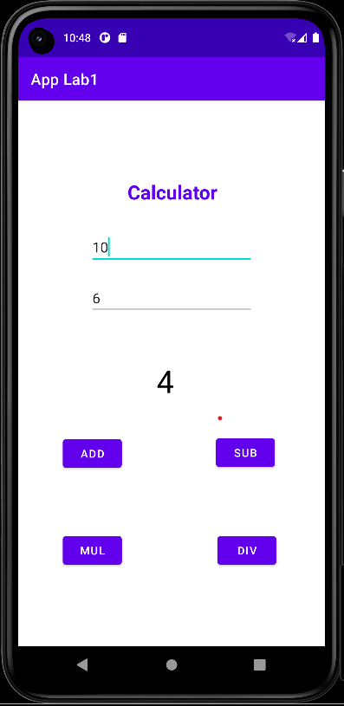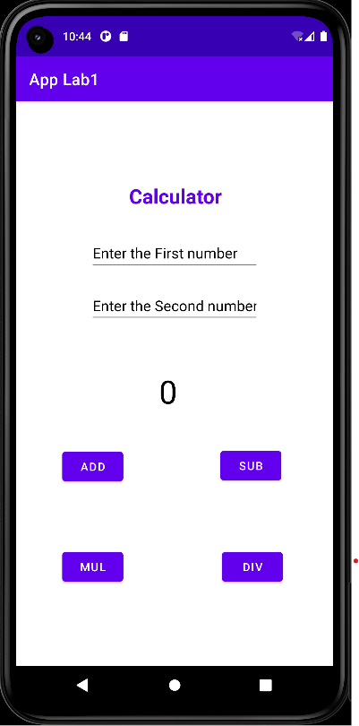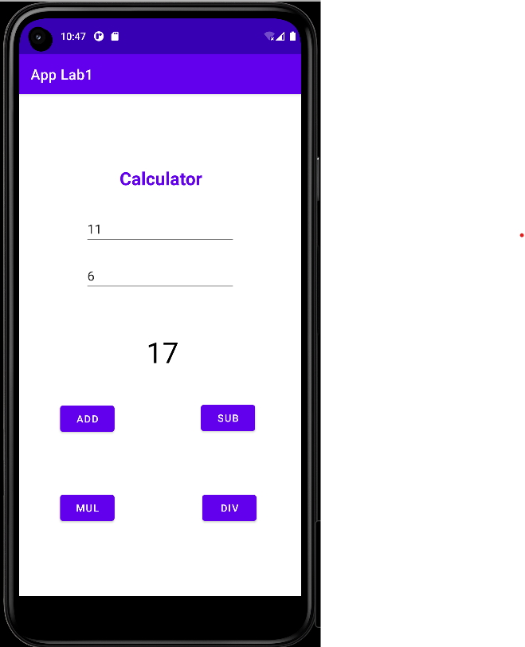

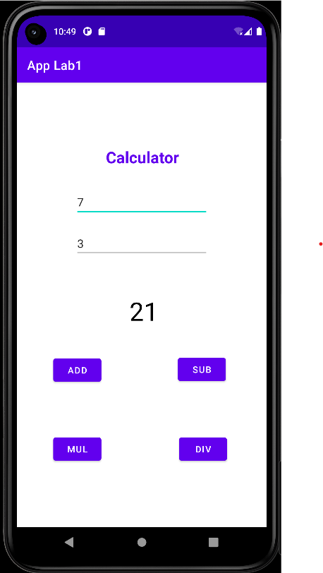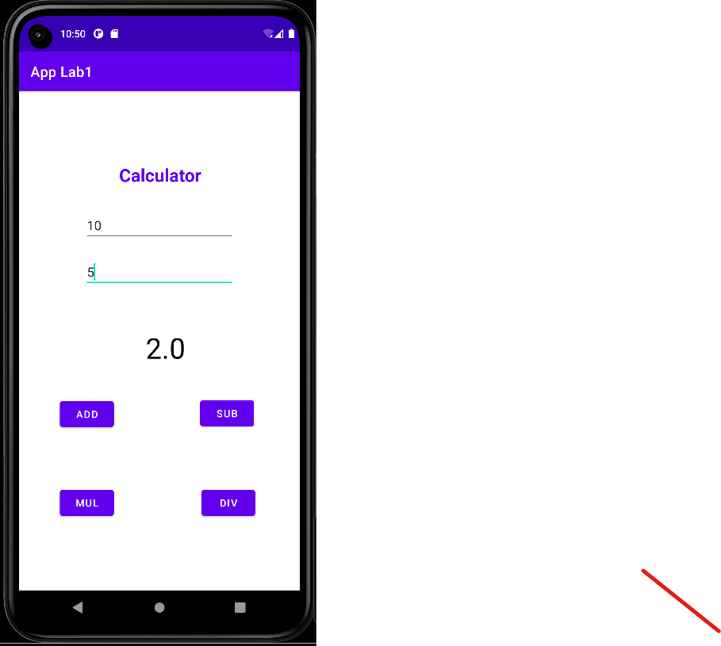

**3. Create a Signup activity with Username and Password. Validation of password should happen based on the following rules: • Password should contain uppercase and lowercase letters. • Password should contain letters and numbers. • Password should contain special characters. • Minimum length of the password (the default value is 8). On successful SIGN UP proceed to the next Login activity. Here the user should SIGN IN using the Username and Password created during signup activity. If the Username and Password are matched then navigate to the next activity which displays a message saying “Successful Login” or else display a toast message saying “Login Failed”. The user is given only two attempts and after that display a toast message saying “Failed Login Attempts” and disable the SIGN IN button. Use Bundle to transfer information from one activity to another**.

**SOURCE CODE**

**XML CODE : activity_main.xml**

<?xml version="1.0" encoding="utf-8"?>

<RelativeLayout xmlns:android="http://schemas.android.com/apk/res/android"

android:layout_width="match_parent"

android:layout_height="match_parent"

xmlns:app="http://schemas.android.com/apk/res-auto"

xmlns:tools="http://schemas.android.com/tools"

tools:context=".SignupActivity">

<TextView

android:id="@+id/textView8"

android:layout_width="171dp"

android:layout_height="85dp"

android:layout_above="@+id/editTextTextPersonName5"

android:layout_alignParentStart="true"

android:layout_alignParentTop="true"

android:layout_alignParentEnd="true"

android:layout_centerHorizontal="true"

android:layout_marginStart="151dp"

android:layout_marginTop="124dp"

android:layout_marginEnd="89dp"

android:text="Signup"

android:textColor="@color/purple_700"

android:textSize="30dp"

android:textStyle="bold" />

<EditText

android:id="@+id/editTextTextPersonName5"

android:layout_width="wrap_content"

android:layout_height="wrap_content"

android:layout_above="@+id/editTextTextPassword"

android:layout_centerHorizontal="true"

android:layout_marginBottom="62dp"

android:ems="10"

android:hint="Email"

android:inputType="textPersonName"

android:text="" />

<Button

android:id="@+id/button6"

android:layout_width="wrap_content"

android:layout_height="wrap_content"

android:layout_alignParentBottom="true"

android:layout_centerHorizontal="true"

android:layout_marginBottom="213dp"

android:text="signup" />

<EditText

android:id="@+id/editTextTextPassword"

android:layout_width="wrap_content"

android:layout_height="wrap_content"

android:layout_above="@+id/button6"

android:layout_alignParentStart="true"

android:layout_centerHorizontal="true"

android:layout_marginStart="99dp"

android:layout_marginBottom="46dp"

android:ems="10"

android:hint="Password"

android:inputType="textPassword" />

</RelativeLayout>

**XML CODE : login.xml**

<?xml version="1.0" encoding="utf-8"?>

<RelativeLayout xmlns:android="http://schemas.android.com/apk/res/android"

xmlns:app="http://schemas.android.com/apk/res-auto"

xmlns:tools="http://schemas.android.com/tools"

android:layout_width="match_parent"

android:layout_height="match_parent"

tools:context=".LoginActivity">

<TextView

android:id="@+id/textView6"

android:layout_width="142dp"

android:layout_height="107dp"

android:layout_above="@+id/editTextTextPersonName3"

android:layout_alignParentStart="true"

android:layout_alignParentTop="true"

android:layout_centerHorizontal="true"

android:layout_marginStart="153dp"

android:layout_marginLeft="30dp"

android:layout_marginTop="105dp"

android:layout_marginBottom="79dp"

android:text="Login"

android:textColor="@color/purple_700"

android:textSize="30dp"

android:textStyle="bold" />

<EditText

android:id="@+id/editTextTextPersonName3"

android:layout_width="wrap_content"

android:layout_height="62dp"

android:layout_above="@+id/editTextTextPassword2"

android:layout_alignParentStart="true"

android:layout_centerHorizontal="true"

android:layout_marginStart="99dp"

android:layout_marginBottom="47dp"

android:ems="10"

android:hint="Email"

android:inputType="textPersonName"

android:text="" />

<Button

android:id="@+id/button5"

android:layout_width="wrap_content"

android:layout_height="wrap_content"

android:layout_alignParentBottom="true"

android:layout_centerHorizontal="true"

android:layout_marginBottom="211dp"

android:text="SIGNIN" />

<EditText

android:id="@+id/editTextTextPassword2"

android:layout_width="wrap_content"

android:layout_height="wrap_content"

android:layout_above="@+id/button5"

android:layout_alignParentStart="true"

android:layout_centerHorizontal="true"

android:layout_marginStart="101dp"

android:layout_marginBottom="58dp"

android:ems="10"

android:inputType="textPassword"

android:hint="Password"/>

</RelativeLayout>

**XML CODE : loginsucess.xml**

<?xml version="1.0" encoding="utf-8"?>

<RelativeLayout xmlns:android="http://schemas.android.com/apk/res/android"

android:layout_width="match_parent"

android:layout_height="match_parent">

<TextView

android:id="@+id/textView7"

android:layout_width="wrap_content"

android:layout_height="91dp"

android:layout_alignParentStart="true"

android:layout_alignParentTop="true"

android:layout_alignParentEnd="true"

android:layout_alignParentBottom="true"

android:layout_centerHorizontal="true"

android:layout_marginStart="42dp"

android:layout_marginTop="216dp"

android:layout_marginEnd="14dp"

android:layout_marginBottom="424dp"

android:text="Login Successful."

android:textSize="32dp"

android:textStyle="bold" />

</RelativeLayout>

**JAVA CODE - MainActivity.java**

package com.technicbvoc.applab1;

import androidx.appcompat.app.AppCompatActivity;

import android.content.Intent;

import android.os.Bundle;

import android.view.View;

import android.widget.Button;

import android.widget.EditText;

import android.widget.Toast;

import java.util.regex.Pattern;

public class SignupActivity extends AppCompatActivity {

EditText Ed_Email,Ed_Password;

Button btn_Signup;

@Override

protected void onCreate(Bundle savedInstanceState) {

super.onCreate(savedInstanceState);

setContentView(R.layout.activity_signup);

Ed_Email=(EditText) findViewById(R.id.editTextTextPersonName5);

Ed_Password=(EditText) findViewById(R.id.editTextTextPassword);

btn_Signup = (Button) findViewById(R.id.button6);

btn_Signup.setOnClickListener(new View.OnClickListener(){

@Override

public void onClick(View v) {

String email =Ed_Email.getText().toString();

String password = Ed_Password.getText().toString();

if(!isValidPassword(password)){

Toast.makeText(SignupActivity.this,"Password Does not match the rules",

Toast.LENGTH_LONG).show();

return;

}

Intent intent= new Intent(SignupActivity.this,LoginActivity.class);

intent.putExtra("email",email);

intent.putExtra("password",password);

startActivity(intent);

}

});

}

Pattern lowercase = Pattern.compile("^.*[a-z].*$");

Pattern uppercase = Pattern.compile("^.*[A-Z].*$");

Pattern number = Pattern.compile("^.*[0-9].*$");

Pattern specialCharacter = Pattern.compile("^.*[^a-zA-Z0-9].*$");

private Boolean isValidPassword(String password){

if (password.length()<8){

return false;

}

if (!lowercase.matcher(password).matches()){

return false;

}

if (!uppercase.matcher(password).matches()){

return false;

}

if (!number.matcher(password).matches()){

return false;

}

if (!specialCharacter.matcher(password).matches()){

return false;

} return true;

}

}

**JAVA CODE - LoginActivity.java**

package com.technicbvoc.applab1;

import androidx.appcompat.app.AppCompatActivity;

import android.content.Intent;

import android.os.Bundle;

import android.view.View;

import android.widget.Button;

import android.widget.EditText;

import android.widget.Toast;

public class LoginActivity extends AppCompatActivity {

EditText Ed_Email, Ed_Password;

Button btn_Signin;

int counter = 2;

@Override

protected void onCreate(Bundle savedInstanceState) {

super.onCreate(savedInstanceState);

setContentView(R.layout.activity_login);

Ed_Email = (EditText) findViewById(R.id.editTextTextPersonName3);

Ed_Password = (EditText) findViewById(R.id.editTextTextPassword2);

btn_Signin = (Button) findViewById(R.id.button5);

String registeredEmail = getIntent().getStringExtra("email");

String registeredPassword = getIntent().getStringExtra("password");

btn_Signin.setOnClickListener(new View.OnClickListener() {

@Override

public void onClick(View v) {

String email = Ed_Email.getText().toString();

String password = Ed_Password.getText().toString();

if (registeredEmail.equals(email) && registeredPassword.equals(password)) {

Intent intent=new Intent(LoginActivity.this,LoginSuccessActivity.class);

startActivity(intent);

} else {

Toast.makeText(LoginActivity.this, "Invalid Credentials",

Toast.LENGTH_LONG).show();

}

counter--;

if (counter == 0) {

Toast.makeText(getBaseContext(), "FAILED LOGIN ATTEMPTS",

Toast.LENGTH_LONG).show();

btn_Signin.setEnabled(false);

}

} });

}}

**JAVA CODE - LoginSuccessful.java**

package com.technicbvoc.applab1;

import androidx.appcompat.app.AppCompatActivity;

import android.os.Bundle;

public class LoginSuccessActivity extends AppCompatActivity {

@Override

protected void onCreate(Bundle savedInstanceState) {

super.onCreate(savedInstanceState);

setContentView(R.layout.activity_login_success);

}

}

**Output:**

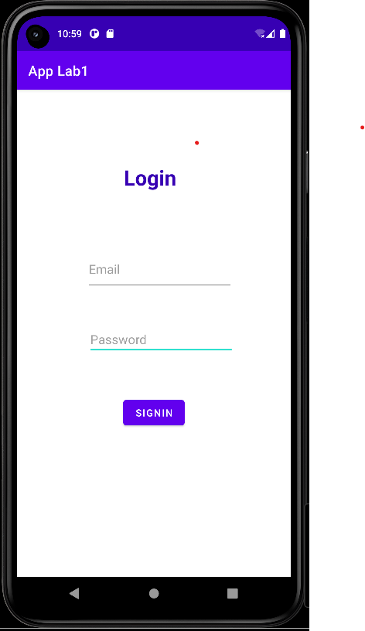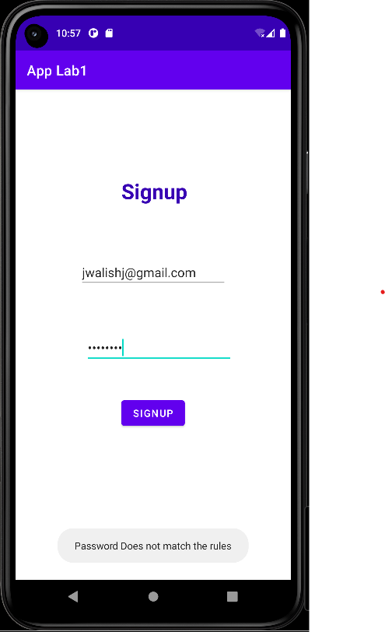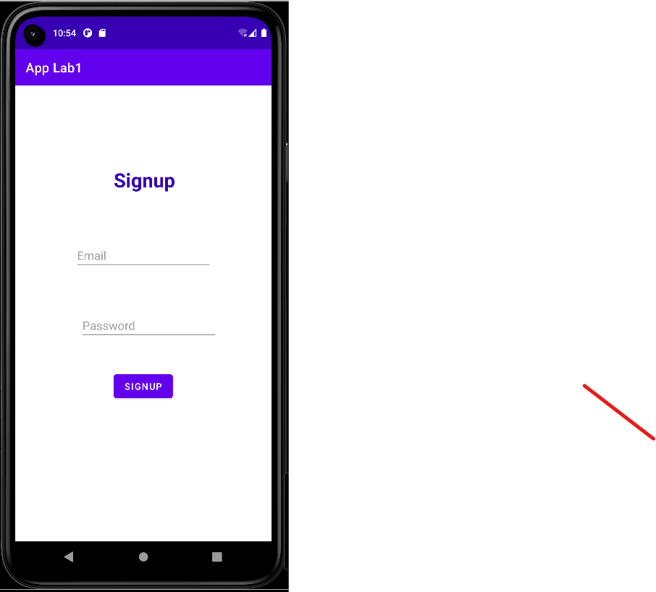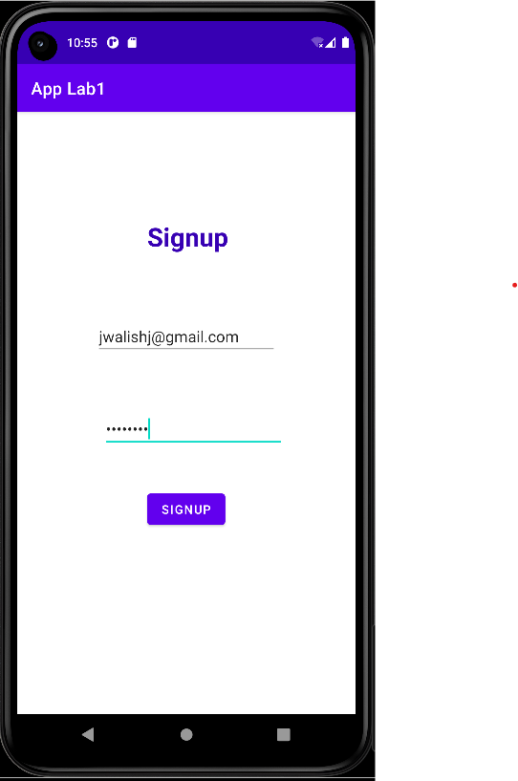

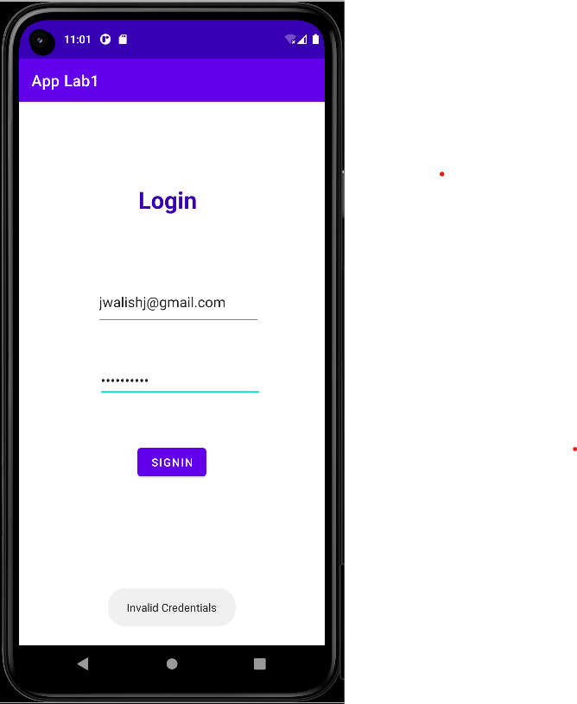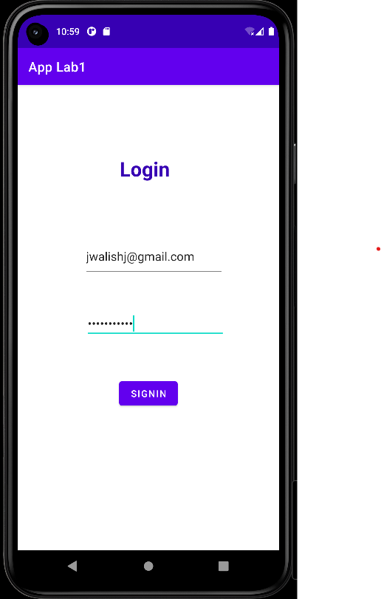

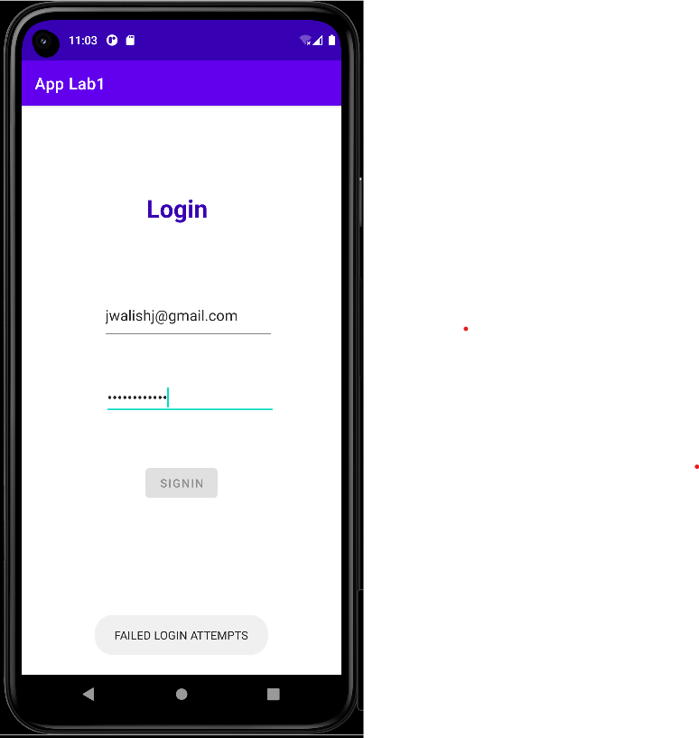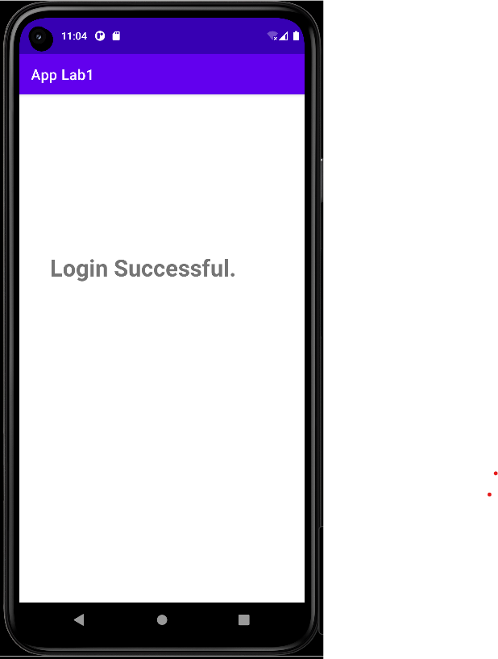

**4. Develop an application to set an image as wallpaper. On click of a button, the wallpaper image should start to change randomly every 30 seconds.**

**SOURCE CODE**

**XML CODE : activity_main.xml**

<?xml version="1.0" encoding="utf-8"?>

<RelativeLayout xmlns:android="http://schemas.android.com/apk/res/android"

xmlns:tools="http://schemas.android.com/tools"

android:id="@+id/relative_layout"

android:layout_width="match_parent"

android:layout_height="match_parent"

android:gravity="center"

tools:context=".WallpaperActivity">

<TextView

android:id="@+id/textView9"

android:layout_width="wrap_content"

android:layout_height="match_parent"

android:layout_above="@+id/button7"

android:layout_alignParentStart="true"

android:layout_alignParentTop="true"

android:layout_alignParentEnd="true"

android:layout_centerHorizontal="true"

android:layout_marginStart="45dp"

android:layout_marginTop="93dp"

android:layout_marginEnd="-1dp"

android:layout_marginBottom="377dp"

android:text="Wallpaper Change Application"

android:textColor="@color/black"

android:textSize="22dp"

android:textStyle="bold" />

<Button

android:id="@+id/button7"

android:layout_width="wrap_content"

android:layout_height="wrap_content"

android:layout_alignParentStart="true"

android:layout_alignParentBottom="true"

android:layout_centerHorizontal="true"

android:layout_marginStart="123dp"

android:layout_marginBottom="125dp"

android:text="CLICK TO CHANGE"

android:textStyle="bold"

android:backgroundTint="@color/purple_700" />

</RelativeLayout>

**JAVA CODE - MainActivity.java**

package com.technicbvoc.applab1;

import androidx.appcompat.app.AppCompatActivity;

import android.app.WallpaperManager;

import android.graphics.Bitmap;

import android.graphics.drawable.BitmapDrawable;

import android.graphics.drawable.Drawable;

import android.os.Bundle;

import android.view.View;

import android.widget.Button;

import java.io.IOException;

import java.util.Timer;

import java.util.TimerTask;

public class WallpaperActivity extends AppCompatActivity {

Button changewallpaper;

Timer mytimer;

Drawable drawable;

WallpaperManager wpm;

int prev=1;

@Override

protected void onCreate(Bundle savedInstanceState) {

super.onCreate(savedInstanceState);

setContentView(R.layout.activity_wallpaper);

mytimer = new Timer();

wpm = WallpaperManager.getInstance(this);

changewallpaper = findViewById(R.id.button7);

changewallpaper.setOnClickListener(new View.OnClickListener() {

@Override

public void onClick(View view) {

setWallpaper();

}

});

} private void setWallpaper() {

mytimer.schedule(new TimerTask() {

@Override

public void run() {

if(prev==1) {

drawable = getResources().getDrawable(R.drawable.a);

prev = 2; }

else if(prev==2) {

drawable = getResources().getDrawable(R.drawable.b);

prev=3;}

else if(prev==3) {

drawable = getResources().getDrawable(R.drawable.c);

prev=4; }

else if(prev==4) {

drawable = getResources().getDrawable(R.drawable.d);

prev=5; }

else if(prev==5) {

drawable = getResources().getDrawable(R.drawable.e);

prev=1;

}

Bitmap wallpaper = ((BitmapDrawable)drawable).getBitmap();

try {

wpm.setBitmap(wallpaper);

} catch (IOException e) {

e.printStackTrace();

}}

},0,3000); } }

**Output:**

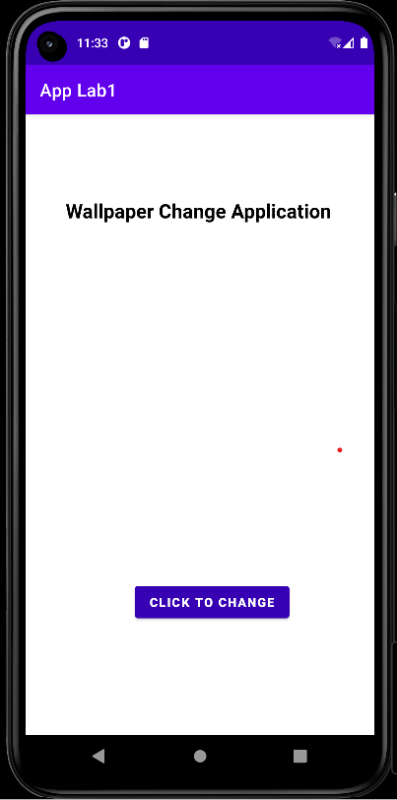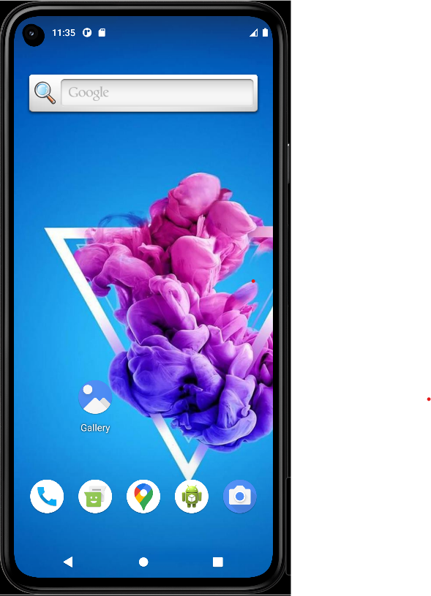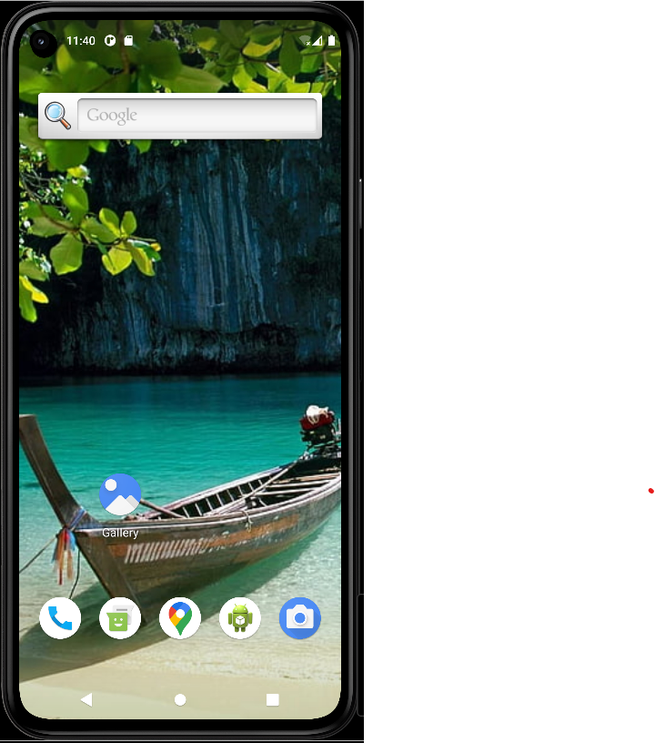

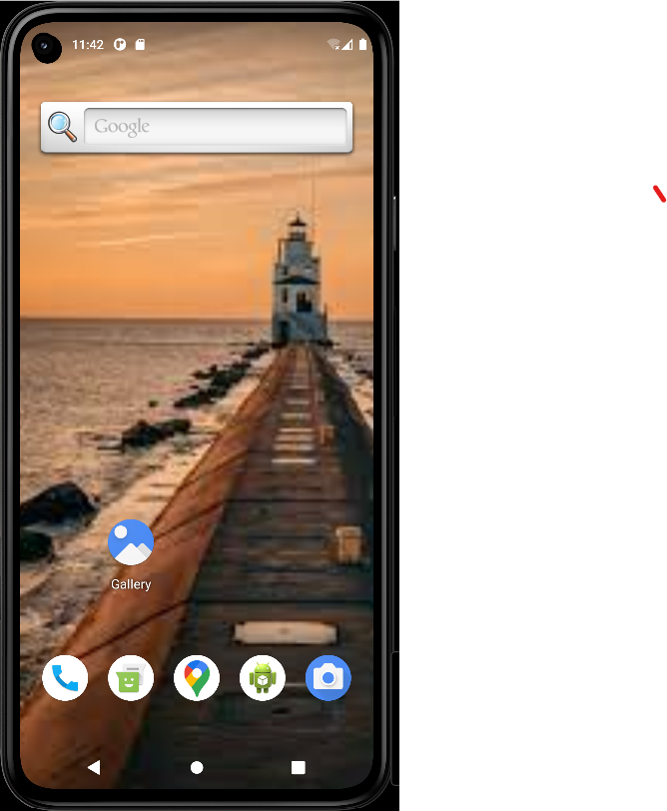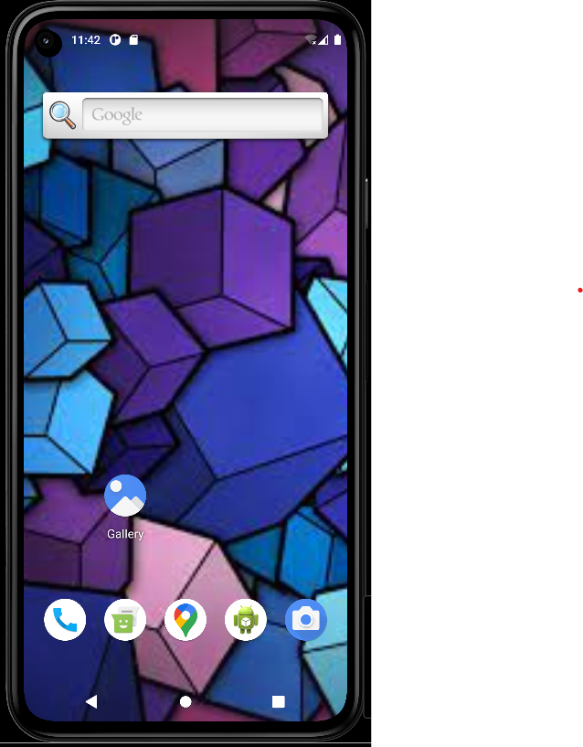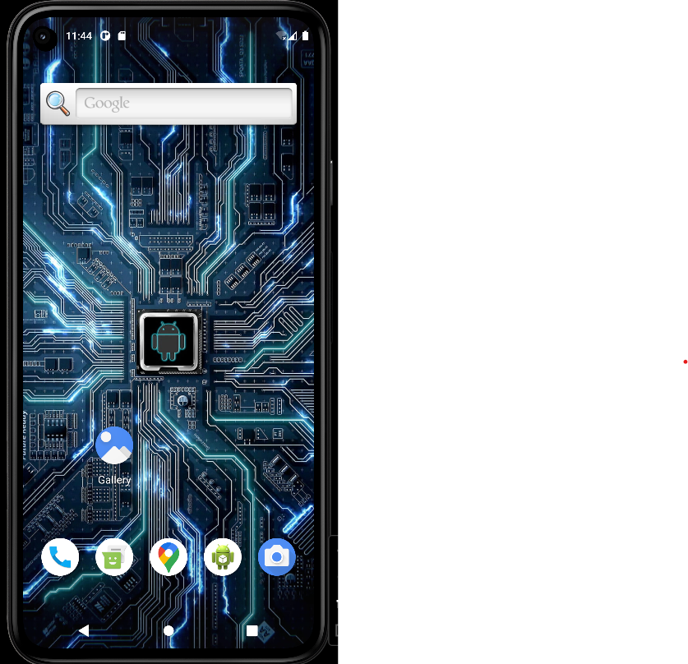

**5. Write a program to create an activity with two buttons START and STOP. On pressing of the START button, the activity must start the counter by displaying the numbers from one and the counter must keep on counting until the STOP button is pressed. Display the counter value in a TextView control.**

**SOURCE CODE**

**XML CODE : activity_main.xml**

<?xml version="1.0" encoding="utf-8"?>

<RelativeLayout

xmlns:android="http://schemas.android.com/apk/res/android"

xmlns:tools="http://schemas.android.com/tools"

xmlns:app="http://schemas.android.com/apk/res-auto"

android:layout_width="match_parent"

android:layout_height="match_parent"

tools:context=".Counter">

<TextView

android:id="@+id/textView12"

android:layout_width="317dp"

android:layout_height="72dp"

android:layout_above="@+id/textView14"

android:layout_alignParentStart="true"

android:layout_centerHorizontal="true"

android:layout_marginStart="66dp"

android:layout_marginTop="96dp"

android:layout_marginBottom="99dp"

android:text="Counter Application"

android:textColor="@color/black"

android:textSize="29dp"

android:textStyle="bold"

app:layout_constraintEnd_toEndOf="parent"

app:layout_constraintStart_toStartOf="parent"

app:layout_constraintTop_toTopOf="parent"

app:layout_constraintVertical_bias="0.0" />

<Button

android:id="@+id/button10"

android:layout_width="wrap_content"

android:layout_height="wrap_content"

android:layout_alignParentStart="true"

android:layout_alignParentBottom="true"

android:layout_marginStart="78dp"

android:layout_marginBottom="203dp"

android:text="START"

android:textStyle="bold"

app:layout_constraintBottom_toBottomOf="parent"

app:layout_constraintEnd_toEndOf="parent"

app:layout_constraintHorizontal_bias="0.195"

app:layout_constraintStart_toStartOf="parent" />

<Button

android:id="@+id/button12"

android:layout_width="wrap_content"

android:layout_height="wrap_content"

android:layout_alignParentEnd="true"

android:layout_alignParentBottom="true"

android:layout_marginEnd="86dp"

android:layout_marginBottom="201dp"

android:text="STOP"

android:textStyle="bold"/>

<TextView

android:id="@+id/textView14"

android:layout_width="88dp"

android:layout_height="40dp"

android:layout_above="@+id/button12"

android:layout_alignParentStart="true"

android:layout_centerHorizontal="true"

android:layout_marginStart="177dp"

android:layout_marginBottom="163dp"

android:text="Count"

android:textColor="@color/black"

android:textSize="28dp" />

</RelativeLayout>

**JAVA CODE - MainActivity.java**

package com.technicbvoc.applab1;

import androidx.appcompat.app.AppCompatActivity;

import android.os.Bundle;

import android.os.Handler;

import android.view.View;

import android.widget.Button;

import android.widget.TextView;

public class Counter extends AppCompatActivity {

Button btnstart, btnstop;

TextView txtcounter;

int i=1;

Handler customHandler=new Handler();

@Override

protected void onCreate(Bundle savedInstanceState) {

super.onCreate(savedInstanceState);

setContentView(R.layout.activity_counter);

btnstart=findViewById(R.id.button10);

btnstop=findViewById(R.id.button12);

txtcounter=findViewById(R.id.textView14);

btnstart.setOnClickListener(new View.OnClickListener() {

@Override

public void onClick(View v) {

customHandler.postDelayed(updateTimerThread,0);

}

});

btnstop.setOnClickListener(new View.OnClickListener() {

@Override

public void onClick(View v) {

customHandler.removeCallbacks(updateTimerThread);

}

});

}

private final Runnable updateTimerThread=new Runnable() {

@Override

public void run() {

txtcounter.setText(""+i);

customHandler.postDelayed(this,1000);

i++;

}

};

}

**Output:**

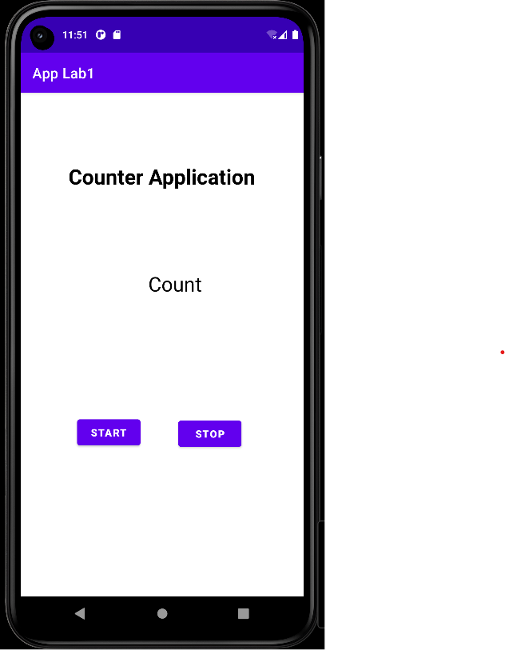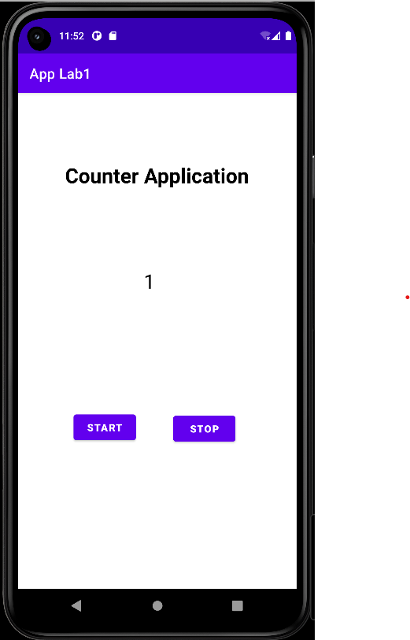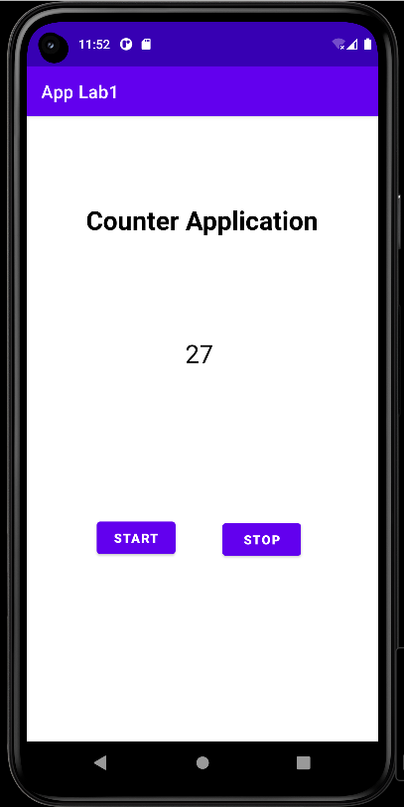

**6. Develop a simple application with one EditText so that the user can write some text in it. Create a button called “Convert Text to Speech” that converts the user input text into voice.**

**SOURCE CODE**

**XML CODE : activity_main.xml**

<?xml version="1.0" encoding="utf-8"?>

<RelativeLayout xmlns:android="http://schemas.android.com/apk/res/android"

xmlns:app="http://schemas.android.com/apk/res-auto"

xmlns:tools="http://schemas.android.com/tools"

android:layout_width="match_parent"

android:layout_height="match_parent"

tools:context=".Convert">

<TextView

android:id="@+id/textView10"

android:layout_width="295dp"

android:layout_height="77dp"

android:layout_above="@+id/editTextTextPersonName4"

android:layout_centerHorizontal="true"

android:layout_marginBottom="59dp"

android:text="TEXT TO SPEECH APP"

android:textColor="@color/black"

android:textSize="25dp"

android:textStyle="bold"

app:layout_constraintBottom_toTopOf="@+id/editTextTextPersonName4"

app:layout_constraintEnd_toEndOf="parent"

app:layout_constraintHorizontal_bias="0.577"

app:layout_constraintStart_toStartOf="parent"

app:layout_constraintTop_toTopOf="parent"

app:layout_constraintVertical_bias="1.0" />

<EditText

android:id="@+id/editTextTextPersonName4"

android:layout_width="237dp"

android:layout_height="74dp"

android:layout_above="@+id/button8"

android:layout_alignParentStart="true"

android:layout_centerHorizontal="true"

android:layout_marginStart="87dp"

android:layout_marginBottom="93dp"

android:ems="10"

android:hint="Enter the text to convert"

android:inputType="textPersonName"

app:layout_constraintEnd_toEndOf="parent"

app:layout_constraintHorizontal_bias="0.505"

app:layout_constraintStart_toStartOf="parent" />

<Button

android:id="@+id/button8"

android:layout_width="wrap_content"

android:layout_height="wrap_content"

android:layout_alignParentBottom="true"

android:layout_centerHorizontal="true"

android:layout_marginBottom="280dp"

android:text="CONVERT TEXT TO SPEECH"

android:textStyle="bold"

android:onClick="convert"

app:layout_constraintBottom_toBottomOf="parent"

app:layout_constraintEnd_toEndOf="parent"

app:layout_constraintHorizontal_bias="0.514"

app:layout_constraintStart_toStartOf="parent" />

</RelativeLayout>

**JAVA CODE - MainActivity.java**

package com.technicbvoc.applab1;

import androidx.appcompat.app.AppCompatActivity;

import android.os.Bundle;

import android.speech.tts.TextToSpeech;

import android.text.Editable;

import android.view.View;

import android.widget.EditText;

import android.widget.Toast;

import java.util.Locale;

public class Convert extends AppCompatActivity {

TextToSpeech t1;

EditText e1;

Editable voiceOut;

@Override

protected void onCreate(Bundle savedInstanceState) {

super.onCreate(savedInstanceState);

setContentView(R.layout.activity_convert);

e1=findViewById(R.id.editTextTextPersonName4);

t1=newTextToSpeech(getApplicationContext(),new TextToSpeech.OnInitListener() {

@Override

public void onInit(int status) {

if(status!=TextToSpeech.ERROR){

t1.setLanguage(Locale.UK);

}

}

});

}

public void convert(View view){

voiceOut=e1.getText();

String tospeak=e1.getText().toString();

Toast.makeText(Convert.this,voiceOut,Toast.LENGTH_LONG).show();

t1.speak(tospeak,TextToSpeech.QUEUE_FLUSH,null);

}

}

**Output:**

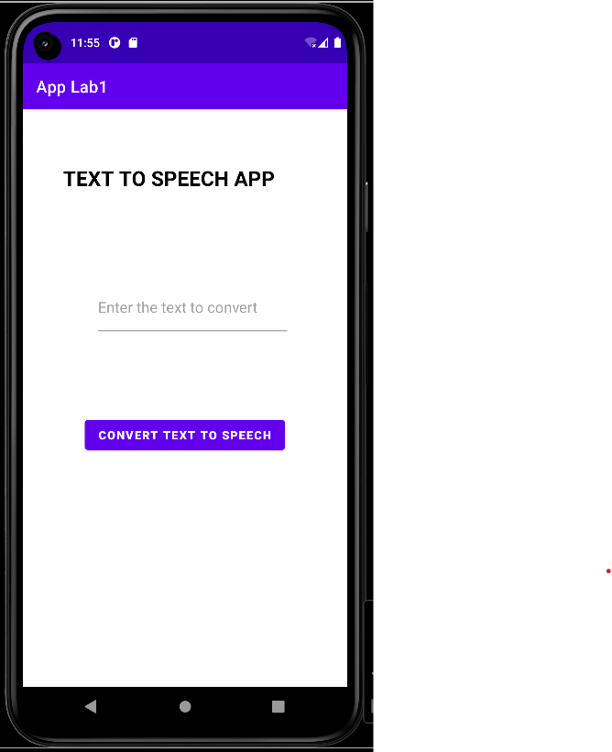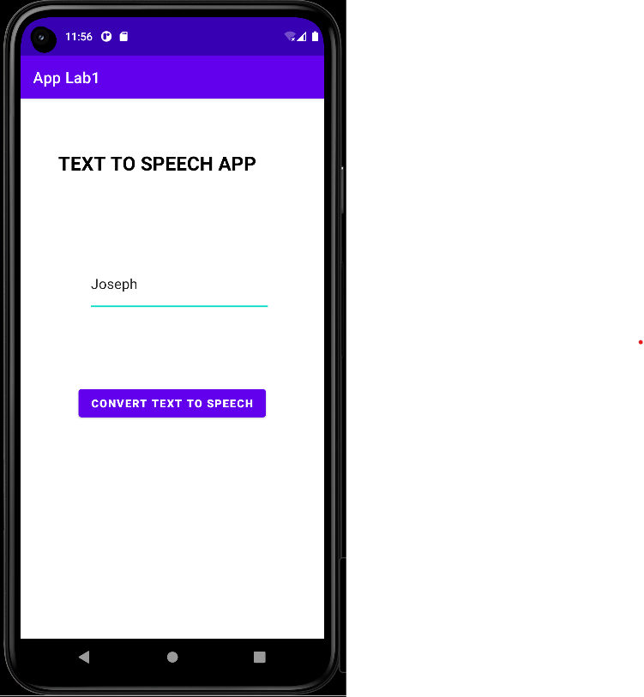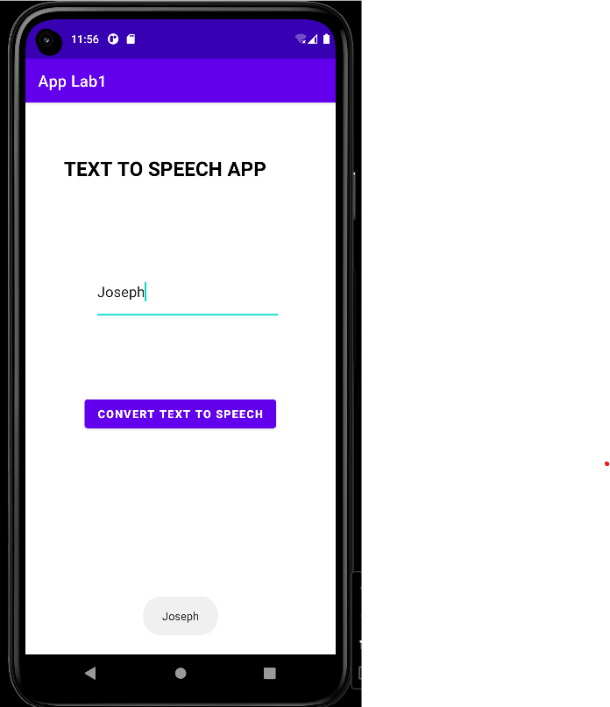

**7. Create an activity like a phone dialer with CALL and SAVE buttons. On pressing the CALL button, it must call the phone number and on pressing the SAVE button it must save the number to the phone contacts.**

**SOURCE CODE**

**XML CODE : activity_main.xml**

<?xml version="1.0" encoding="utf-8"?>

<androidx.constraintlayout.widget.ConstraintLayout xmlns:android="http://schemas.android.com/apk/res/android"

xmlns:app="http://schemas.android.com/apk/res-auto"

xmlns:tools="http://schemas.android.com/tools"

android:layout_width="match_parent"

android:layout_height="match_parent"

tools:context=".Call">

<Button

android:id="@+id/button32"

android:layout_width="wrap_content"

android:layout_height="wrap_content"

android:text="SAVE"

app:layout_constraintBottom_toBottomOf="parent"

app:layout_constraintEnd_toEndOf="parent"

app:layout_constraintHorizontal_bias="0.839"

app:layout_constraintStart_toStartOf="parent"

app:layout_constraintTop_toTopOf="parent"

app:layout_constraintVertical_bias="0.841" />

<Button

android:id="@+id/button31"

android:layout_width="wrap_content"

android:layout_height="wrap_content"

android:text="CALL"

app:layout_constraintBottom_toBottomOf="parent"

app:layout_constraintEnd_toEndOf="parent"

app:layout_constraintHorizontal_bias="0.151"

app:layout_constraintStart_toStartOf="parent"

app:layout_constraintTop_toTopOf="parent"

app:layout_constraintVertical_bias="0.841" />

<Button

android:id="@+id/button30"

android:layout_width="wrap_content"

android:layout_height="wrap_content"

android:text="*"

android:onClick="inputNumber"

app:layout_constraintBottom_toBottomOf="parent"

app:layout_constraintEnd_toEndOf="parent"

app:layout_constraintHorizontal_bias="0.839"

app:layout_constraintStart_toStartOf="parent"

app:layout_constraintTop_toTopOf="parent"

app:layout_constraintVertical_bias="0.724" />

<Button

android:id="@+id/button29"

android:layout_width="wrap_content"

android:layout_height="wrap_content"

android:text="0"

android:onClick="inputNumber"

app:layout_constraintBottom_toBottomOf="parent"

app:layout_constraintEnd_toEndOf="parent"

app:layout_constraintHorizontal_bias="0.498"

app:layout_constraintStart_toStartOf="parent"

app:layout_constraintTop_toTopOf="parent"

app:layout_constraintVertical_bias="0.724" />

<Button

android:id="@+id/button28"

android:layout_width="wrap_content"

android:layout_height="wrap_content"

android:text="#"

android:onClick="inputNumber"

app:layout_constraintBottom_toBottomOf="parent"

app:layout_constraintEnd_toEndOf="parent"

app:layout_constraintHorizontal_bias="0.151"

app:layout_constraintStart_toStartOf="parent"

app:layout_constraintTop_toTopOf="parent"

app:layout_constraintVertical_bias="0.724" />

<Button

android:id="@+id/button27"

android:layout_width="wrap_content"

android:layout_height="wrap_content"

android:text="9"

android:onClick="inputNumber"

app:layout_constraintBottom_toBottomOf="parent"

app:layout_constraintEnd_toEndOf="parent"

app:layout_constraintHorizontal_bias="0.839"

app:layout_constraintStart_toStartOf="parent"

app:layout_constraintTop_toTopOf="parent"

app:layout_constraintVertical_bias="0.61" />

<Button

android:id="@+id/button26"

android:layout_width="wrap_content"

android:layout_height="wrap_content"

android:text="8"

android:onClick="inputNumber"

app:layout_constraintBottom_toBottomOf="parent"

app:layout_constraintEnd_toEndOf="parent"

app:layout_constraintHorizontal_bias="0.498"

app:layout_constraintStart_toStartOf="parent"

app:layout_constraintTop_toTopOf="parent"

app:layout_constraintVertical_bias="0.61" />

<Button

android:id="@+id/button25"

android:layout_width="wrap_content"

android:layout_height="wrap_content"

android:text="7"

android:onClick="inputNumber"

app:layout_constraintBottom_toBottomOf="parent"

app:layout_constraintEnd_toEndOf="parent"

app:layout_constraintHorizontal_bias="0.151"

app:layout_constraintStart_toStartOf="parent"

app:layout_constraintTop_toTopOf="parent"

app:layout_constraintVertical_bias="0.61" />

<Button

android:id="@+id/button24"

android:layout_width="wrap_content"

android:layout_height="wrap_content"

android:text="6"

android:onClick="inputNumber"

app:layout_constraintBottom_toBottomOf="parent"

app:layout_constraintEnd_toEndOf="parent"

app:layout_constraintHorizontal_bias="0.839"

app:layout_constraintStart_toStartOf="parent"

app:layout_constraintTop_toTopOf="parent"

app:layout_constraintVertical_bias="0.499" />

<Button

android:id="@+id/button23"

android:layout_width="wrap_content"

android:layout_height="wrap_content"

android:text="5"

android:onClick="inputNumber"

app:layout_constraintBottom_toBottomOf="parent"

app:layout_constraintEnd_toEndOf="parent"

app:layout_constraintHorizontal_bias="0.498"

app:layout_constraintStart_toStartOf="parent"

app:layout_constraintTop_toTopOf="parent"

app:layout_constraintVertical_bias="0.499" />

<Button

android:id="@+id/button21"

android:layout_width="wrap_content"

android:layout_height="wrap_content"

android:text="3"

android:onClick="inputNumber"

app:layout_constraintBottom_toBottomOf="parent"

app:layout_constraintEnd_toEndOf="parent"

app:layout_constraintHorizontal_bias="0.839"

app:layout_constraintStart_toStartOf="parent"

app:layout_constraintTop_toTopOf="parent"

app:layout_constraintVertical_bias="0.39" />

<Button

android:id="@+id/button20"

android:layout_width="wrap_content"

android:layout_height="wrap_content"

android:text="2"

android:onClick="inputNumber"

app:layout_constraintBottom_toBottomOf="parent"

app:layout_constraintEnd_toEndOf="parent"

app:layout_constraintHorizontal_bias="0.498"

app:layout_constraintStart_toStartOf="parent"

app:layout_constraintTop_toTopOf="parent"

app:layout_constraintVertical_bias="0.39" />

<TextView

android:id="@+id/textView11"

android:layout_width="300dp"

android:layout_height="71dp"

android:text="Call Application"

android:textColor="@color/purple_700"

android:textSize="35dp"

android:textStyle="bold"

app:layout_constraintBottom_toBottomOf="parent"

app:layout_constraintEnd_toEndOf="parent"

app:layout_constraintHorizontal_bias="0.639"

app:layout_constraintStart_toStartOf="parent"

app:layout_constraintTop_toTopOf="parent"

app:layout_constraintVertical_bias="0.069" />

<EditText

android:id="@+id/editTextTextPersonName7"

android:layout_width="wrap_content"

android:layout_height="wrap_content"

android:ems="10"

android:hint=""

android:inputType="textPersonName"

app:layout_constraintBottom_toBottomOf="parent"

app:layout_constraintEnd_toEndOf="parent"

app:layout_constraintHorizontal_bias="0.303"

app:layout_constraintStart_toStartOf="parent"

app:layout_constraintTop_toTopOf="parent"

app:layout_constraintVertical_bias="0.206" />

<Button

android:id="@+id/button18"

android:layout_width="wrap_content"

android:layout_height="wrap_content"

android:layout_marginEnd="40dp"

android:layout_marginBottom="544dp"

android:text="clear"

app:layout_constraintBottom_toBottomOf="parent"

app:layout_constraintEnd_toEndOf="parent" />

<Button

android:id="@+id/button19"

android:layout_width="wrap_content"

android:layout_height="wrap_content"

android:text="1"

android:onClick="inputNumber"

app:layout_constraintBottom_toBottomOf="parent"

app:layout_constraintEnd_toEndOf="parent"

app:layout_constraintHorizontal_bias="0.151"

app:layout_constraintStart_toStartOf="parent"

app:layout_constraintTop_toTopOf="parent"

app:layout_constraintVertical_bias="0.39" />

<Button

android:id="@+id/button22"

android:layout_width="wrap_content"

android:layout_height="wrap_content"

android:text="4"

android:onClick="inputNumber"

app:layout_constraintBottom_toBottomOf="parent"

app:layout_constraintEnd_toEndOf="parent"

app:layout_constraintHorizontal_bias="0.151"

app:layout_constraintStart_toStartOf="parent"

app:layout_constraintTop_toTopOf="parent"

app:layout_constraintVertical_bias="0.499" />

</androidx.constraintlayout.widget.ConstraintLayout>

**JAVA CODE - MainActivity.java**

package com.technicbvoc.applab1;

import androidx.appcompat.app.AppCompatActivity;

import android.content.Intent;

import android.net.Uri;

import android.os.Bundle;

import android.provider.ContactsContract;

import android.view.View;

import android.widget.Button;

import android.widget.EditText;

public class Call extends AppCompatActivity {

EditText phoneNumberEditText;

Button clearBtn,callBtn,saveBtn;

@Override

protected void onCreate(Bundle savedInstanceState) {

super.onCreate(savedInstanceState);

setContentView(R.layout.activity_call);

phoneNumberEditText=findViewById(R.id.editTextTextPersonName7);

callBtn=findViewById(R.id.button31);

saveBtn=findViewById(R.id.button32);

clearBtn=findViewById(R.id.button18);

clearBtn.setOnClickListener(new View.OnClickListener() {

@Override public void onClick(View v)

{

phoneNumberEditText.setText("");

}

}); callBtn.setOnClickListener(new View.OnClickListener() {

@Override

public void onClick(View v) {

String phoneNumber=phoneNumberEditText.getText().toString();

Intent intent=new Intent(Intent.ACTION_DIAL);

intent.setData(Uri.parse("tel:"+phoneNumber));

startActivity(intent); }

}); saveBtn.setOnClickListener(new View.OnClickListener() {

@Override

public void onClick(View v) {

String phoneNumber=phoneNumberEditText.getText().toString();

Intent intent=new Intent(Intent.ACTION_INSERT);

intent.setType(ContactsContract.Contacts.CONTENT_TYPE);

intent.putExtra(ContactsContract.Intents.Insert.PHONE,phoneNumber);

startActivity(intent);

}

});

}

public void inputNumber(View V){

Button btn=(Button)V;

String digit=btn.getText().toString();

String phoneNumber=phoneNumberEditText.getText().toString();

phoneNumberEditText.setText(phoneNumber +digit);

} }

**Output:**

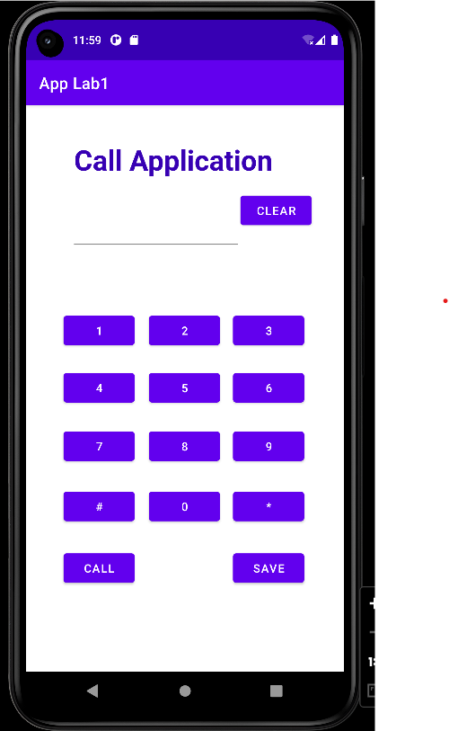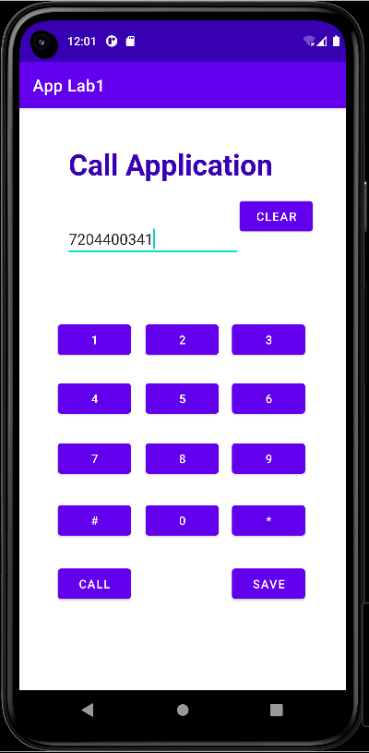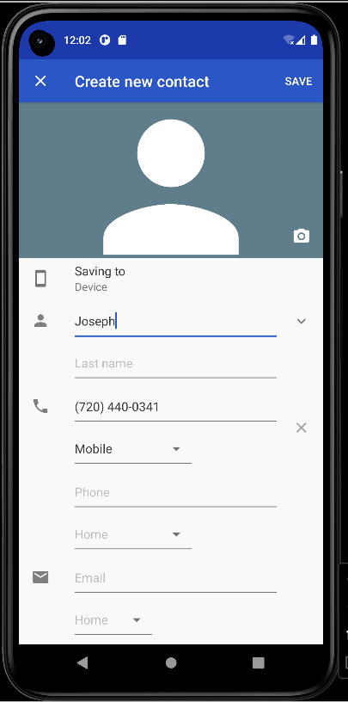

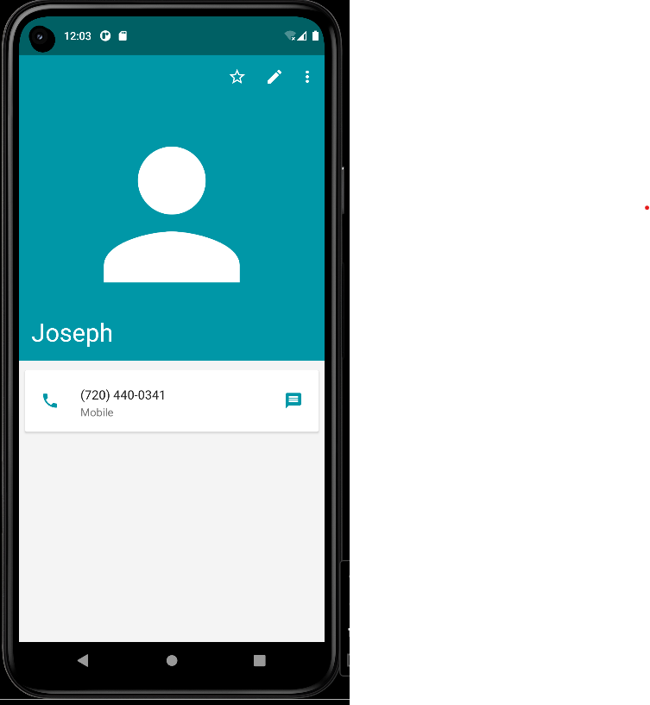

**8. Write a program to enter Medicine Name, Date and Time of the Day as input from the user and store it in the SQLite database. Input for Time of the Day should be either Morning or Afternoon or Evening or Night.**

**SOURCE CODE**

**XML CODE : activity_main.xml**

<?xml version="1.0" encoding="utf-8"?>

<RelativeLayout xmlns:android="http://schemas.android.com/apk/res/android"

xmlns:app="http://schemas.android.com/apk/res-auto"

xmlns:tools="http://schemas.android.com/tools"

android:layout_width="match_parent"

android:layout_height="match_parent"

tools:context=".Medicine">

<TextView

android:id="@+id/textView2"

android:layout_width="310dp"

android:layout_height="78dp"

android:layout_alignParentStart="true"

android:layout_alignParentTop="true"

android:layout_alignParentEnd="true"

android:layout_alignParentBottom="true"

android:layout_centerHorizontal="true"

android:layout_marginStart="69dp"

android:layout_marginTop="60dp"

android:layout_marginEnd="32dp"

android:layout_marginBottom="593dp"

android:text="Medicine Database"

android:textColor="@color/black"

android:textSize="28dp"

android:textStyle="bold" />

<TextView

android:id="@+id/textView3"

android:layout_width="128dp"

android:layout_height="wrap_content"

android:layout_alignParentStart="true"

android:layout_alignParentTop="true"

android:layout_alignParentEnd="true"

android:layout_alignParentBottom="true"

android:layout_marginStart="21dp"

android:layout_marginTop="168dp"

android:layout_marginEnd="262dp"

android:layout_marginBottom="528dp"

android:text="Medicine Name"

android:textStyle="bold"

android:textSize="16dp"

android:textColor="@color/black"/>

<TextView

android:id="@+id/textView4"

android:layout_width="wrap_content"

android:layout_height="wrap_content"

android:layout_alignParentStart="true"

android:layout_alignParentTop="true"

android:layout_alignParentEnd="true"

android:layout_alignParentBottom="true"

android:layout_centerHorizontal="true"

android:layout_marginStart="24dp"

android:layout_marginTop="230dp"

android:layout_marginEnd="286dp"

android:layout_marginBottom="453dp"

android:text="Date"

android:textStyle="bold"

android:textSize="16dp"

android:textColor="@color/black"/>

<TextView

android:id="@+id/textView5"

android:layout_width="66dp"

android:layout_height="37dp"

android:layout_alignParentStart="true"

android:layout_alignParentTop="true"

android:layout_alignParentEnd="true"

android:layout_alignParentBottom="true"

android:layout_marginStart="32dp"

android:layout_marginTop="304dp"

android:layout_marginEnd="313dp"

android:layout_marginBottom="390dp"

android:text="Time"

android:textStyle="bold"

android:textSize="16dp"

android:textColor="@color/black"/>

<EditText

android:id="@+id/medicine_name"

android:layout_width="wrap_content"

android:layout_height="wrap_content"

android:layout_alignParentStart="true"

android:layout_alignParentTop="true"

android:layout_alignParentEnd="true"

android:layout_alignParentBottom="true"

android:layout_marginStart="167dp"

android:layout_marginTop="163dp"

android:layout_marginEnd="34dp"

android:layout_marginBottom="523dp"

android:ems="10"

android:inputType="textPersonName"

/>

<EditText

android:id="@+id/date"

android:layout_width="wrap_content"

android:layout_height="wrap_content"

android:layout_alignParentTop="true"

android:layout_alignParentEnd="true"

android:layout_alignParentBottom="true"

android:layout_marginTop="229dp"

android:layout_marginEnd="31dp"

android:layout_marginBottom="457dp"

android:ems="10"

android:hint="DD/MM/YYYY"

android:inputType="date" />

<EditText

android:id="@+id/time"

android:layout_width="wrap_content"

android:layout_height="wrap_content"

android:layout_alignParentStart="true"

android:layout_alignParentTop="true"

android:layout_alignParentEnd="true"

android:layout_alignParentBottom="true"

android:layout_marginStart="171dp"

android:layout_marginTop="304dp"

android:layout_marginEnd="29dp"

android:layout_marginBottom="382dp"

android:ems="10"

android:inputType="textPersonName" />

<Button

android:id="@+id/btn_save"

android:layout_width="wrap_content"

android:layout_height="wrap_content"

android:layout_alignParentStart="true"

android:layout_alignParentEnd="true"

android:layout_alignParentBottom="true"

android:layout_marginStart="239dp"

android:layout_marginEnd="84dp"

android:layout_marginBottom="249dp"

android:text="Save" />

<Button

android:id="@+id/btn_show"

android:layout_width="wrap_content"

android:layout_height="wrap_content"

android:layout_alignParentStart="true"

android:layout_alignParentTop="true"

android:layout_alignParentEnd="true"

android:layout_alignParentBottom="true"

android:layout_marginStart="81dp"

android:layout_marginTop="435dp"

android:layout_marginEnd="242dp"

android:layout_marginBottom="248dp"

android:text="Show" />

<TextView

android:id="@+id/lbl_data"

android:layout_width="253dp"

android:layout_height="117dp"

android:layout_alignParentStart="true"

android:layout_alignParentTop="true"

android:layout_alignParentEnd="true"

android:layout_alignParentBottom="true"

android:layout_marginStart="65dp"

android:layout_marginTop="534dp"

android:layout_marginEnd="93dp"

android:layout_marginBottom="80dp"

android:text="Data"

android:textStyle="bold"

android:textSize="16dp"

android:textColor="@color/black"/>

</RelativeLayout>

**JAVA CODE - MainActivity.java**

package com.technicbvoc.applab1;

import androidx.appcompat.app.AppCompatActivity;

import android.content.ContentValues;

import android.database.Cursor;

import android.database.sqlite.SQLiteDatabase;

import android.os.Bundle;

import android.view.View;

import android.widget.Button;

import android.widget.EditText;

import android.widget.TextView;

import android.widget.Toast;

public class Medicine extends AppCompatActivity {

EditText Medicine,Date,Time;

TextView Data;

Button Save,Show;

MyDatabase database;

@Override

protected void onCreate(Bundle savedInstanceState) {

super.onCreate(savedInstanceState);

setContentView(R.layout.activity_medicine);

Medicine = findViewById(R.id.medicine_name);

Date = findViewById(R.id.date);

Time = findViewById(R.id.time);

Save = findViewById(R.id.btn_save);

Show = findViewById(R.id.btn_show);

Data = findViewById(R.id.lbl_data);

database = new MyDatabase(getBaseContext(),MyDatabase.DATABASE_NAME,null,1);

Save.setOnClickListener(new View.OnClickListener() {

@Override

public void onClick(View view) {

String medicine = Medicine.getText().toString();

String date = Date.getText().toString();

String time = Time.getText().toString();

SQLiteDatabase mydatabase = database.getWritableDatabase();

ContentValues cv = new ContentValues();

cv.put("NAME",medicine);

cv.put("DATE",date);

cv.put("TIME",time);

mydatabase.insert("MEDICINE_NAMES",null,cv);

Toast.makeText(getApplicationContext(), "Data Saved", Toast.LENGTH_SHORT).show();

}

});

Show.setOnClickListener(new View.OnClickListener() {

@Override

public void onClick(View view) {

SQLiteDatabase mydatabase = database.getReadableDatabase();

Cursor cursor = mydatabase.query("MEDICINE_NAMES", new String[]

{"NAME ", " DATE", " TIME"}, null, null, null, null, null);

Data.setText("NAME\tDATE\tTIME\n");

while(cursor.moveToNext()){

Data.append(cursor.getString(0)+"\t");

Data.append(cursor.getString(1)+"\t");

Data.append(cursor.getString(2)+"\n");}}

});

}

}

**JAVA CODE - MyDatabase.java**

package com.technicbvoc.applab1;

import android.content.Context;

import android.database.sqlite.SQLiteDatabase;

import android.database.sqlite.SQLiteOpenHelper;

import androidx.annotation.Nullable;

public class MyDatabase extends SQLiteOpenHelper {

public static String DATABASE_NAME = "medicine.db";

public MyDatabase(@Nullable Context context, @Nullable String name, @Nullable

SQLiteDatabase.CursorFactory factory,int version){

super(context,name,factory,version);

}

@Override

public void onCreate(SQLiteDatabase db) {

db.execSQL("CREATE TABLE MEDICINE_NAMES(NAME TEXT,DATE TEXT,TIME TEXT)");

}

@Override

public void onUpgrade(SQLiteDatabase sqLiteDatabase, int i, int i1) {

}

}

**Output:**

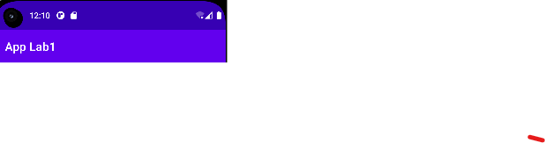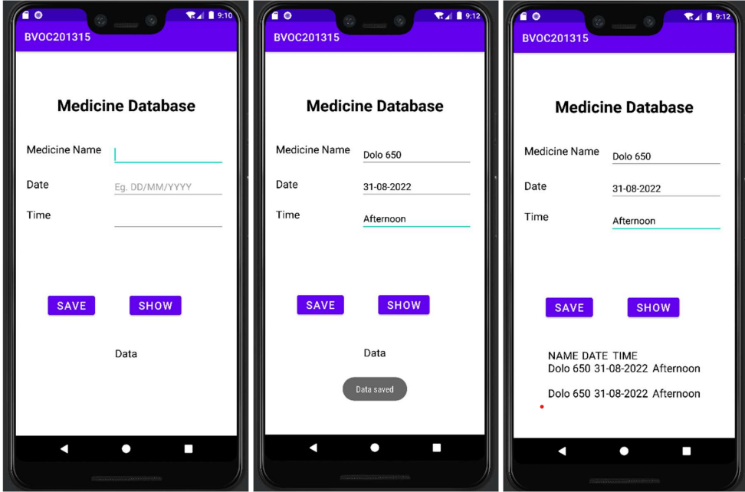

**9. Develop a content provider application with an activity called “Meeting Schedule” which takes Date, Time and Meeting Agenda as input from the user and store this information into the SQLite database. Create another application with an activity called “Meeting Info” having Date Picker control, which on the selection of a date should display the Meeting Agenda information for that particular date, else it should display a toast message saying “No Meeting on this Date”.**

**SOURCE CODE**

**XML CODE : activity_meeting_schedule.xml**

<?xml version="1.0" encoding="utf-8"?>

<RelativeLayout xmlns:android="http://schemas.android.com/apk/res/android"

xmlns:app="http://schemas.android.com/apk/res-auto"

xmlns:tools="http://schemas.android.com/tools"

android:layout_width="match_parent"

android:layout_height="match_parent"

tools:context=".Meeting_Schedule">

<TextView

android:id="@+id/textView13"

android:layout_width="249dp"

android:layout_height="59dp"

android:layout_alignParentTop="true"

android:layout_alignParentBottom="true"

android:layout_centerHorizontal="true"

android:layout_marginTop="38dp"

android:layout_marginBottom="634dp"

android:text="Schedule Meeting"

android:textColor="@color/black"

android:textSize="28dp"

android:textStyle="bold"

app:layout_constraintBottom_toBottomOf="parent"

app:layout_constraintEnd_toEndOf="parent"

app:layout_constraintHorizontal_bias="0.574"

app:layout_constraintStart_toStartOf="parent"

app:layout_constraintTop_toTopOf="parent"

app:layout_constraintVertical_bias="0.074" />

<TextView

android:id="@+id/textView15"

android:layout_width="87dp"

android:layout_height="49dp"

android:layout_alignParentStart="true"

android:layout_alignParentTop="true"

android:layout_marginStart="35dp"

android:layout_marginTop="132dp"

android:layout_marginEnd="26dp"

android:layout_toStartOf="@+id/editTextDate"

android:text="Date"

android:textColor="@color/black"

android:textSize="20dp"

app:layout_constraintBottom_toBottomOf="parent"

app:layout_constraintEnd_toEndOf="parent"

app:layout_constraintHorizontal_bias="0.099"

app:layout_constraintStart_toStartOf="parent"

app:layout_constraintTop_toTopOf="parent"

app:layout_constraintVertical_bias="0.255" />

<TextView

android:id="@+id/textView16"

android:layout_width="88dp"

android:layout_height="54dp"

android:layout_alignParentStart="true"

android:layout_alignParentTop="true"

android:layout_marginStart="33dp"

android:layout_marginTop="196dp"

android:layout_marginEnd="26dp"

android:layout_toStartOf="@+id/editTextTime"

android:text="Time"

android:textColor="@color/black"

android:textSize="20dp"

app:layout_constraintBottom_toBottomOf="parent"

app:layout_constraintEnd_toEndOf="parent"

app:layout_constraintHorizontal_bias="0.099"

app:layout_constraintStart_toStartOf="parent"

app:layout_constraintTop_toTopOf="parent"

app:layout_constraintVertical_bias="0.353" />

<TextView

android:id="@+id/textView17"

android:layout_width="90dp"

android:layout_height="50dp"

android:layout_alignParentStart="true"

android:layout_alignParentTop="true"

android:layout_alignParentEnd="true"

android:layout_alignParentBottom="true"

android:layout_marginStart="32dp"

android:layout_marginTop="270dp"

android:layout_marginEnd="289dp"

android:layout_marginBottom="411dp"

android:text="Agenda"

android:textColor="@color/black"

android:textSize="20dp"

app:layout_constraintBottom_toBottomOf="parent"

app:layout_constraintEnd_toEndOf="parent"

app:layout_constraintHorizontal_bias="0.09"

app:layout_constraintStart_toStartOf="parent"

app:layout_constraintTop_toTopOf="parent"

app:layout_constraintVertical_bias="0.462" />

<EditText

android:id="@+id/editTextDate"

android:layout_width="233dp"

android:layout_height="47dp"

android:layout_alignParentTop="true"

android:layout_alignParentEnd="true"

android:layout_alignParentBottom="true"

android:layout_marginTop="131dp"

android:layout_marginEnd="30dp"

android:layout_marginBottom="553dp"

android:ems="10"

android:inputType="date"

android:hint="DD.MM.YYYY"

app:layout_constraintBottom_toBottomOf="parent"

app:layout_constraintEnd_toEndOf="parent"

app:layout_constraintHorizontal_bias="0.747"

app:layout_constraintStart_toStartOf="parent"

app:layout_constraintTop_toTopOf="parent"

app:layout_constraintVertical_bias="0.257" />

<EditText

android:id="@+id/editTextTime"

android:layout_width="230dp"

android:layout_height="55dp"

android:layout_alignParentTop="true"

android:layout_alignParentEnd="true"

android:layout_marginTop="196dp"

android:layout_marginEnd="31dp"

android:ems="10"

android:inputType="time"

android:hint="tt.mm.ss"

app:layout_constraintBottom_toBottomOf="parent"

app:layout_constraintEnd_toEndOf="parent"

app:layout_constraintHorizontal_bias="0.734"

app:layout_constraintStart_toStartOf="parent"

app:layout_constraintTop_toTopOf="parent"

app:layout_constraintVertical_bias="0.353" />

<EditText

android:id="@+id/editTextTextPersonName6"

android:layout_width="233dp"

android:layout_height="50dp"

android:layout_alignParentStart="true"

android:layout_alignParentTop="true"

android:layout_alignParentEnd="true"

android:layout_alignParentBottom="true"

android:layout_marginStart="150dp"

android:layout_marginTop="270dp"

android:layout_marginEnd="28dp"

android:layout_marginBottom="410dp"

android:ems="10"

android:inputType="textPersonName"

android:hint=""

app:layout_constraintBottom_toBottomOf="parent"

app:layout_constraintEnd_toEndOf="parent"

app:layout_constraintHorizontal_bias="0.747"

app:layout_constraintStart_toStartOf="parent"

app:layout_constraintTop_toTopOf="parent"

app:layout_constraintVertical_bias="0.462" />

<Button

android:id="@+id/button9"

android:layout_width="wrap_content"

android:layout_height="wrap_content"

android:layout_alignParentStart="true"

android:layout_alignParentBottom="true"

android:layout_marginStart="60dp"

android:layout_marginBottom="31dp"

android:text="save"

app:layout_constraintBottom_toBottomOf="parent"

app:layout_constraintEnd_toEndOf="parent"

app:layout_constraintHorizontal_bias="0.154"

app:layout_constraintStart_toStartOf="parent"

app:layout_constraintTop_toTopOf="parent"

app:layout_constraintVertical_bias="0.904" />

<Button

android:id="@+id/button11"

android:layout_width="wrap_content"

android:layout_height="wrap_content"

android:layout_alignParentStart="true"

android:layout_alignParentTop="true"

android:layout_alignParentEnd="true"

android:layout_alignParentBottom="true"

android:layout_marginStart="256dp"

android:layout_marginTop="653dp"

android:layout_marginEnd="67dp"

android:layout_marginBottom="30dp"

android:text="view"

app:layout_constraintBottom_toBottomOf="parent"

app:layout_constraintEnd_toEndOf="parent"

app:layout_constraintHorizontal_bias="0.782"

app:layout_constraintStart_toStartOf="parent"

app:layout_constraintTop_toTopOf="parent"

app:layout_constraintVertical_bias="0.904" />

<CalendarView

android:id="@+id/calendarView"

android:layout_width="333dp"

android:layout_height="290dp"

android:layout_alignParentEnd="true"

android:layout_alignParentBottom="true"

android:layout_centerHorizontal="true"

android:layout_marginEnd="28dp"

android:layout_marginBottom="100dp" />

</RelativeLayout>

**XML CODE : activity_meeting_info.xml**

<?xml version="1.0" encoding="utf-8"?>

<RelativeLayout xmlns:android="http://schemas.android.com/apk/res/android"

xmlns:app="http://schemas.android.com/apk/res-auto"

xmlns:tools="http://schemas.android.com/tools"

android:layout_width="match_parent"

android:layout_height="match_parent"

tools:context=".Meeting_Info">

<TextView

android:id="@+id/textView18"

android:layout_width="184dp"

android:layout_height="wrap_content"

android:layout_alignParentStart="true"

android:layout_alignParentTop="true"

android:layout_alignParentBottom="true"

android:layout_centerHorizontal="true"

android:layout_marginStart="116dp"

android:layout_marginTop="49dp"

android:layout_marginBottom="626dp"

android:text="Meeting Info"

android:textColor="@color/black"

android:textSize="28dp"

android:textStyle="bold" />

<EditText

android:id="@+id/editTextDate2"

android:layout_width="184dp"

android:layout_height="wrap_content"

android:layout_alignParentStart="true"

android:layout_alignParentTop="true"

android:layout_alignParentEnd="true"

android:layout_alignParentBottom="true"

android:layout_centerHorizontal="true"

android:layout_marginStart="103dp"

android:layout_marginTop="165dp"

android:layout_marginEnd="124dp"

android:layout_marginBottom="521dp"

android:ems="10"

android:hint="DD/MM/YYYY"

android:inputType="date" />

<CalendarView

android:id="@+id/calendarView2"

android:layout_width="337dp"

android:layout_height="282dp"

android:layout_alignParentTop="true"

android:layout_centerHorizontal="true"

android:layout_marginTop="230dp" />

<Button

android:id="@+id/button13"

android:layout_width="118dp"

android:layout_height="wrap_content"

android:layout_alignParentStart="true"

android:layout_alignParentTop="true"

android:layout_alignParentEnd="true"

android:layout_alignParentBottom="true"

android:layout_centerHorizontal="true"

android:layout_marginStart="146dp"

android:layout_marginTop="528dp"

android:layout_marginEnd="147dp"

android:layout_marginBottom="148dp"

android:text="Search" />

</RelativeLayout>

**JAVA CODE – Meeting_Schedule.java**

package com.technicbvoc.applab1;

import androidx.annotation.NonNull;

import androidx.appcompat.app.AppCompatActivity;

import android.content.Context;

import android.content.Intent;

import android.os.Bundle;

import android.view.View;

import android.view.inputmethod.InputMethodManager;

import android.widget.Button;

import android.widget.CalendarView;

import android.widget.EditText;

import android.widget.Toast;

public class Meeting_Schedule extends AppCompatActivity {

EditText date, time, agenda;

DataBaseConn dbc;

CalendarView calendarView;

Button save, show;

@Override

protected void onCreate(Bundle savedInstanceState) {

super.onCreate(savedInstanceState);

setContentView(R.layout.activity_meeting_schedule);

date=findViewById(R.id.editTextDate);

time=findViewById(R.id.editTextTime);

agenda=findViewById(R.id.editTextTextPersonName6);

save=findViewById(R.id.button9);

show = findViewById(R.id.button11);

calendarView=findViewById(R.id.calendarView);

dbc = new DataBaseConn(getApplicationContext());

calendarView.setVisibility(View.INVISIBLE);

date.setOnClickListener(new View.OnClickListener() {

@Override

public void onClick(View v) {

closeKeyBoard();

calendarView.setVisibility(View.VISIBLE);

calendarView.setOnDateChangeListener(new CalendarView.OnDateChangeListener() {

@Override

public void onSelectedDayChange(@NonNull CalendarView view, int year, int month, int dayOfMonth) {

String d = dayOfMonth + "/" + (month + 1) + "/" + year;

date.setText(d);

calendarView.setVisibility(View.INVISIBLE);

}

});

}

});

save.setOnClickListener(new View.OnClickListener() {

@Override

public void onClick(View v) {

String mdate, mTime, mAgenda;

mdate = date.getText().toString();

mTime = time.getText().toString();

mAgenda = agenda.getText().toString();

boolean insert = dbc.insertvalue(mdate, mTime, mAgenda);

if (insert) {

Toast.makeText(getApplicationContext(),"Data-Inserted", Toast.LENGTH_SHORT)

.show();

} else {

Toast.makeText(getApplicationContext(),"Data_NOT_Inserted", Toast.LENGTH_SHORT)

.show();

}

}

});

show.setOnClickListener(new View.OnClickListener() {

@Override

public void onClick(View view) {

Intent intent = new Intent(Meeting_Schedule.this, Meeting_Info.class);

startActivity(intent);

}

});

}

private void closeKeyBoard() {

View view = this.getCurrentFocus();

if (view != null) {

InputMethodManager imm = (InputMethodManager) this.getSystemService(Context.INPUT_METHOD_SERVICE);

imm.hideSoftInputFromWindow(view.getWindowToken(), 0);

}

} }

**JAVA CODE – Meeting_info.java**

package com.technicbvoc.applab1;

import androidx.annotation.NonNull;

import androidx.appcompat.app.AppCompatActivity;

import android.annotation.SuppressLint;

import android.database.Cursor;

import android.os.Bundle;

import android.view.View;

import android.widget.*;

public class Meeting_Info extends AppCompatActivity {

EditText date;

CalendarView cal;

Button btn1;

DataBaseConn dbc;

TextView t;

@Override

protected void onCreate(Bundle savedInstanceState) {

super.onCreate(savedInstanceState);

setContentView(R.layout.activity_meeting_info);

date=findViewById(R.id.editTextDate2);

cal=findViewById(R.id.calendarView2);

btn1=findViewById(R.id.button13);

dbc=new DataBaseConn(getApplicationContext());

cal.setOnDateChangeListener(new CalendarView.OnDateChangeListener() {

@Override

public void onSelectedDayChange(@NonNull CalendarView view, int year, int month, int dayOfMonth) {

String d=dayOfMonth+"/"+(month+1)+"/"+year;

date.setText(d);

}

});

btn1.setOnClickListener(new View.OnClickListener() {

@SuppressLint("Range")

@Override

public void onClick(View v) {

String d1=date.getText().toString();

StringBuffer res=new StringBuffer();

Cursor c=dbc.fetch(d1);

int count=c.getCount();

c.moveToFirst();

if(count>0) {

do {

res.append(c.getString(c.getColumnIndex("agenda"))+"\t"+"at"+"\t"+c.getString(c.getColumnIndex("time")));

res.append("\n");

}while (c.moveToNext());

Toast.makeText(getApplicationContext(), res, Toast.LENGTH_LONG).show();

}

else

{

Toast.makeText(getApplicationContext(), "No Meeting on This Day....",Toast.

LENGTH_SHORT).show();

}}});

}

}

**JAVA CODE - DataBaseConn.java**

package com.technicbvoc.applab1;

import android.content.ContentValues;

import android.content.Context;

import android.database.Cursor;

import android.database.sqlite.*;

public class DataBaseConn extends SQLiteOpenHelper {

public DataBaseConn(Context context) {

super(context,"MeetingDB.db",null,1);

}

@Override

public void onCreate(SQLiteDatabase db) {

db.execSQL("create Table meetingTbl(date TEXT,time TEXT, agenda TEXT)");

}

@Override

public void onUpgrade(SQLiteDatabase db, int oldVersion, int newVersion) {

db.execSQL("drop Table if exists meetingTbl");

}

public boolean insertvalue(String d, String t, String agd){

SQLiteDatabase DB=this.getWritableDatabase();

ContentValues cv = new ContentValues();

cv.put("date",d);

cv.put("time",t);

cv.put("agenda",agd);

long res=DB.insert("meetingTbl",null,cv); //query to insert

if(res==-1){

return false;

}

else

return true;

}

public Cursor fetch(String d){

SQLiteDatabase DB=this.getReadableDatabase();

Cursor c = DB.rawQuery("Select time,agenda from meetingTbl where date='"+d+"'",null);

return c;

}

}

**Output:**

****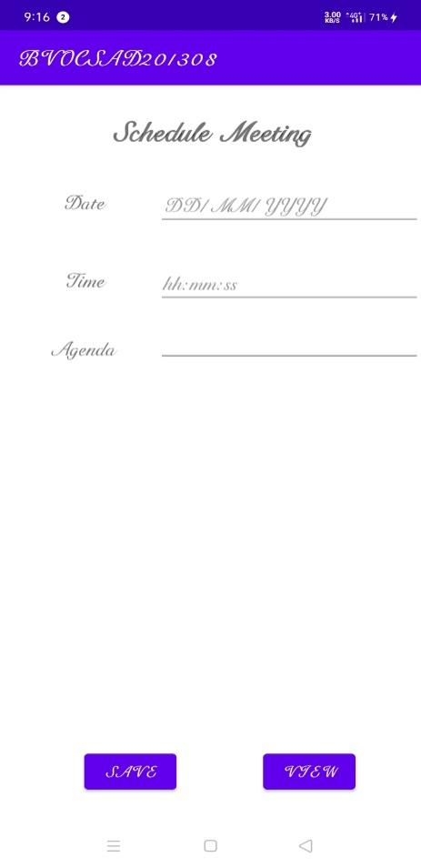 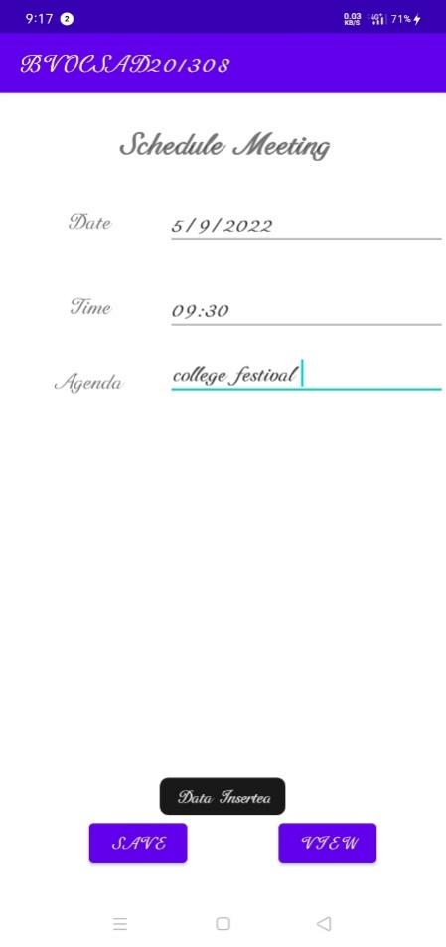 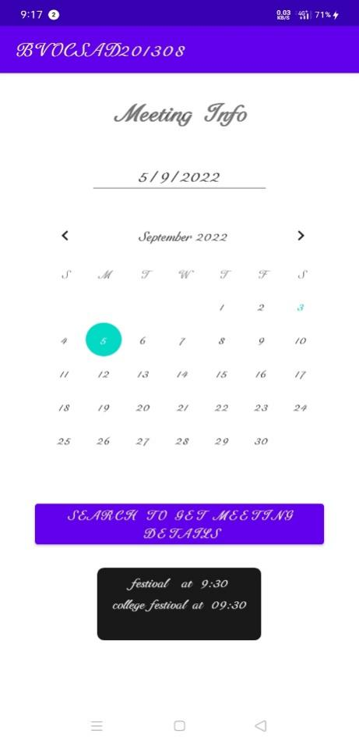

**10. Create an application to receive an incoming SMS, which is notified to the user. On clicking this SMS notification, the message content and the number should be displayed on the screen. Use appropriate emulator control to send the SMS message to your application.**

**SOURCE CODE**

**XML CODE : activity_main.xml**

<?xml version="1.0" encoding="utf-8"?>

<androidx.constraintlayout.widget.ConstraintLayout xmlns:android="http://schemas.android.com/apk/res/android"

xmlns:tools="http://schemas.android.com/tools"

android:layout_width="match_parent"

android:layout_height="match_parent"

xmlns:app="http://schemas.android.com/apk/res-auto"

tools:context=".SMS">

<TextView

android:id="@+id/textView1"

android:layout_width="300dp"

android:layout_height="50dp"

android:text="Sending SMS Application"

android:textColor="@color/black"

android:textSize="25sp"

android:textStyle="bold"

app:layout_constraintBottom_toBottomOf="parent"

app:layout_constraintEnd_toEndOf="parent"

app:layout_constraintHorizontal_bias="0.495"

app:layout_constraintStart_toStartOf="parent"

app:layout_constraintTop_toTopOf="parent"

app:layout_constraintVertical_bias="0.102" />

<TextView

android:id="@+id/textView2"

android:layout_width="136dp"

android:layout_height="58dp"

android:text="@string/txtroll"

android:textColorHint="@color/black"

android:textSize="25sp"

android:textStyle="bold"

app:layout_constraintBottom_toBottomOf="parent"

app:layout_constraintEnd_toEndOf="parent"

app:layout_constraintHorizontal_bias="0.596"

app:layout_constraintStart_toStartOf="parent"

app:layout_constraintTop_toTopOf="parent"

app:layout_constraintVertical_bias="0.176" />

<EditText

android:id="@+id/editText"

android:layout_width="229dp"

android:layout_height="54dp"

android:hint="Enter Phone Number"

android:phoneNumber="true"

android:textColor="@color/black"

android:textSize="16dp"

app:layout_constraintBottom_toBottomOf="parent"

app:layout_constraintEnd_toEndOf="parent"

app:layout_constraintHorizontal_bias="0.45"

app:layout_constraintStart_toStartOf="parent"

app:layout_constraintTop_toTopOf="parent"

app:layout_constraintVertical_bias="0.536" />

<EditText

android:id="@+id/editText2"

android:layout_width="228dp"

android:layout_height="wrap_content"

android:hint="Enter SMS"

android:textSize="20dp"

app:layout_constraintBottom_toBottomOf="parent"

app:layout_constraintEnd_toEndOf="parent"

app:layout_constraintHorizontal_bias="0.448"

app:layout_constraintStart_toStartOf="parent"

app:layout_constraintTop_toTopOf="parent"

app:layout_constraintVertical_bias="0.66" />

<Button

android:id="@+id/btnSendSMS"

android:layout_width="wrap_content"

android:layout_height="wrap_content"

android:text="Send Sms"

app:layout_constraintBottom_toBottomOf="parent"

app:layout_constraintEnd_toEndOf="parent"

app:layout_constraintHorizontal_bias="0.445"

app:layout_constraintStart_toStartOf="parent"

app:layout_constraintTop_toTopOf="parent"

app:layout_constraintVertical_bias="0.783" />

<ImageView

android:id="@+id/imageView3"

android:layout_width="145dp"

android:layout_height="134dp"

android:src="@drawable/jo"

app:layout_constraintBottom_toBottomOf="parent"

app:layout_constraintEnd_toEndOf="parent"

app:layout_constraintHorizontal_bias="0.432"

app:layout_constraintStart_toStartOf="parent"

app:layout_constraintTop_toTopOf="parent"

app:layout_constraintVertical_bias="0.333" />

</androidx.constraintlayout.widget.ConstraintLayout>

**JAVA CODE - MainActivity.java**

package com.technicbvoc.applab1;

import android.Manifest;

import android.content.pm.PackageManager;

import android.os.Bundle;

import android.app.Activity;

import android.telephony.SmsManager;

import android.view.View;

import android.widget.Button;

import android.widget.EditText;

import android.widget.Toast;

import androidx.core.app.ActivityCompat;

import androidx.core.content.ContextCompat;

public class SMS extends Activity {

private static final int MY_PERMISSIONS_REQUEST_SEND_SMS =0 ;

Button sendBtn;

EditText txtphoneNo;

EditText txtMessage;

String phoneNo;

String message;

@Override

protected void onCreate(Bundle savedInstanceState) {

super.onCreate(savedInstanceState);

setContentView(R.layout.activity_sms);

sendBtn = (Button) findViewById(R.id.btnSendSMS);

txtphoneNo = (EditText) findViewById(R.id.editText);

txtMessage = (EditText) findViewById(R.id.editText2);

sendBtn.setOnClickListener(new View.OnClickListener() {

public void onClick(View view) {

sendSMSMessage();

}

});

}

protected void sendSMSMessage() {

phoneNo = txtphoneNo.getText().toString();

message = txtMessage.getText().toString();

if (ContextCompat.checkSelfPermission(this, Manifest.permission.SEND_SMS)

!= PackageManager.PERMISSION_GRANTED) {

if (ActivityCompat.shouldShowRequestPermissionRationale(this,

Manifest.permission.SEND_SMS)) {

} else {

ActivityCompat.requestPermissions(this,

new String[]{Manifest.permission.SEND_SMS},

MY_PERMISSIONS_REQUEST_SEND_SMS);

}

}

}

@Override

public void onRequestPermissionsResult(int requestCode,String permissions[], int[]

grantResults) {

switch (requestCode) {

case MY_PERMISSIONS_REQUEST_SEND_SMS: {

if (grantResults.length > 0

&& grantResults[0] == PackageManager.PERMISSION_GRANTED) {

SmsManager smsManager = SmsManager.getDefault();

smsManager.sendTextMessage(phoneNo, null, message, null, null);

Toast.makeText(getApplicationContext(), "SMS sent.",

Toast.LENGTH_LONG).show();

} else {

Toast.makeText(getApplicationContext(),

"SMS failed, please try again.", Toast.LENGTH_LONG).show();

return;

}

}

}

}

}

**Output:**

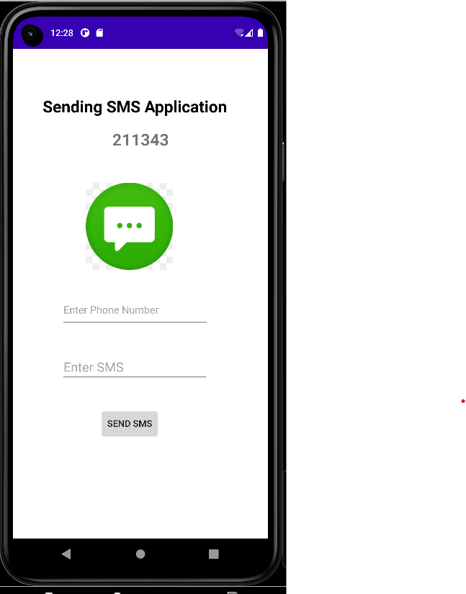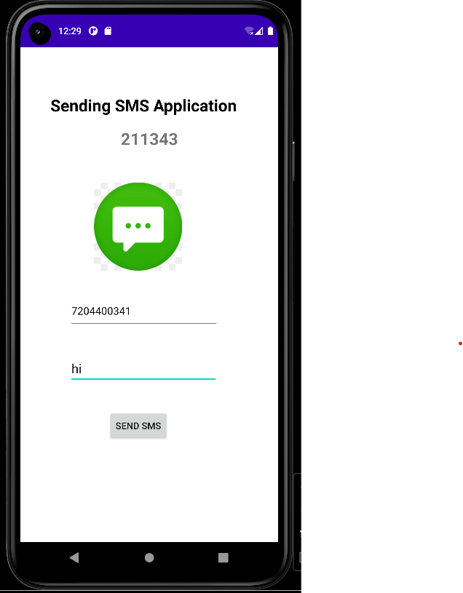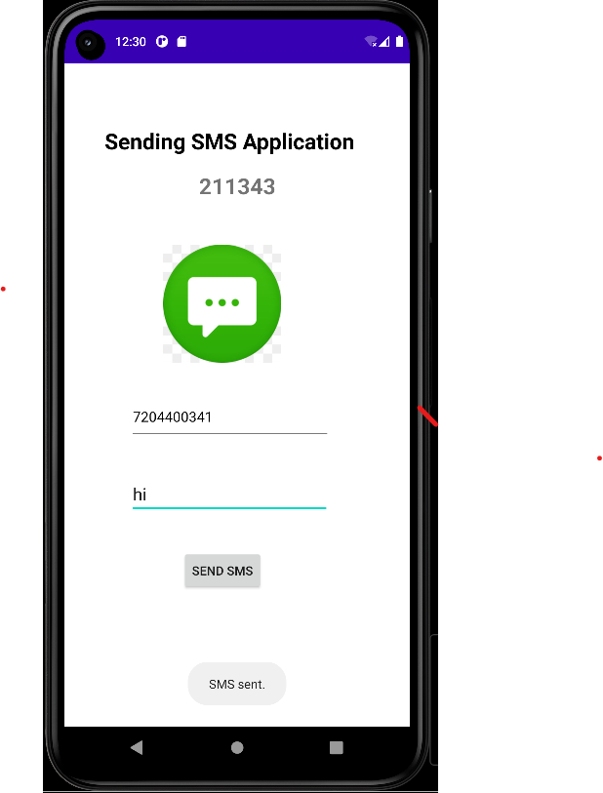

**11. Write a program to create an activity having a Text box, and also Save, Open and Create buttons. The user has to write some text in the Text box. On pressing the Create button the text should be saved as a text file in SDcard. On subsequent changes to the text, the Save button should be pressed to store the latest content to the same file. On pressing the Open button, it should display the contents from the previously stored files in the Text box. If the user tries to save the contents in the Textbox to a file without creating it, then a toast message has to be displayed saying “First Create a File”.**

**SOURCE CODE**

**XML CODE : activity_main.xml**

<?xml version="1.0" encoding="utf-8"?>

<RelativeLayout xmlns:android="http://schemas.android.com/apk/res/android"

xmlns:app="http://schemas.android.com/apk/res-auto"

xmlns:tools="http://schemas.android.com/tools"

android:layout_width="match_parent"

android:layout_height="match_parent"

tools:context=".Create_file">

<TextView

android:id="@+id/textView20"

android:layout_width="181dp"

android:layout_height="74dp"

android:layout_alignParentStart="true"

android:layout_alignParentTop="true"

android:layout_alignParentEnd="true"

android:layout_alignParentBottom="true"

android:layout_centerHorizontal="true"

android:layout_marginStart="143dp"

android:layout_marginTop="78dp"

android:layout_marginEnd="87dp"

android:layout_marginBottom="579dp"

android:fontFamily="sans-serif-medium"

android:text="Text Box"

android:textColor="#E50DED"

android:textSize="33dp"

android:textStyle="bold|italic" />

<Button

android:id="@+id/btnCreate"

android:layout_width="150dp"

android:layout_height="wrap_content"

android:layout_alignParentStart="true"

android:layout_alignParentTop="true"

android:layout_alignParentBottom="true"

android:layout_centerHorizontal="true"

android:layout_marginStart="132dp"

android:layout_marginTop="172dp"

android:layout_marginBottom="511dp"

android:backgroundTint="#ED0B5E"

android:text="create"

android:textColorHint="#ED3A02" />

<EditText

android:id="@+id/editTextTextPersonName10"

android:layout_width="238dp"

android:layout_height="57dp"

android:layout_alignParentStart="true"

android:layout_alignParentTop="true"

android:layout_alignParentEnd="true"

android:layout_alignParentBottom="true"

android:layout_centerHorizontal="true"

android:layout_marginStart="93dp"

android:layout_marginTop="274dp"

android:layout_marginEnd="80dp"

android:layout_marginBottom="399dp"

android:ems="10"

android:hint="Enter the text"

android:inputType="textPersonName" />

<Button

android:id="@+id/btnSave"

android:layout_width="wrap_content"

android:layout_height="wrap_content"

android:layout_alignParentStart="true"

android:layout_alignParentTop="true"

android:layout_alignParentEnd="true"

android:layout_alignParentBottom="true"

android:layout_marginStart="96dp"

android:layout_marginTop="364dp"

android:layout_marginEnd="221dp"

android:layout_marginBottom="319dp"

android:backgroundTint="#0FEC18"

android:text="save" />

<Button

android:id="@+id/btnLoad"

android:layout_width="wrap_content"

android:layout_height="wrap_content"

android:layout_alignParentStart="true"

android:layout_alignParentTop="true"

android:layout_alignParentEnd="true"

android:layout_alignParentBottom="true"

android:layout_marginStart="247dp"

android:layout_marginTop="363dp"

android:layout_marginEnd="70dp"

android:layout_marginBottom="320dp"

android:backgroundTint="#24B7FF"

android:text="read" />

</RelativeLayout>

**JAVA CODE - MainActivity.java**

package com.technicbvoc.applab1;

import android.content.SharedPreferences;

import android.os.Bundle;

import android.view.View;

import android.widget.Button;

import android.widget.EditText;

import android.widget.Toast;

import androidx.appcompat.app.AppCompatActivity;

public class Create_file extends AppCompatActivity implements View.OnClickListener {

EditText etText;

Button btnSave, btnLoad,btcreate;

SharedPreferences sPref;

final String SAVED_TEXT = "saved_text";

@Override

protected void onCreate(Bundle savedInstanceState) {

super.onCreate(savedInstanceState);

setContentView(R.layout.activity_create_file);

etText = (EditText) findViewById(R.id.editTextTextPersonName10);

btnSave = (Button) findViewById(R.id.btnSave);

btnSave.setOnClickListener(this);

btnLoad = (Button) findViewById(R.id.btnLoad);

btcreate=(Button) findViewById(R.id.btnCreate);

btcreate.setOnClickListener(this);

btnLoad.setOnClickListener(this);

loadText();

}

@Override

public void onClick(View v) {

switch (v.getId()) {

case R.id.btnSave: saveText();

break;

case R.id.btnCreate: createtext();

break;

case R.id.btnLoad: loadText();

break;

default: break;

}

}

void createtext() {

sPref = getPreferences(MODE_PRIVATE);

SharedPreferences.Editor ed = sPref.edit();

ed.putString(SAVED_TEXT, etText.getText().toString());

ed.commit();

Toast.makeText(this, "Text created", Toast.LENGTH_SHORT).show();

}

void saveText() {

if (etText!=null){

sPref = getPreferences(MODE_PRIVATE);

SharedPreferences.Editor ed = sPref.edit();

ed.putString(SAVED_TEXT, etText.getText().toString());

ed.commit();

Toast.makeText(this, "Text saved", Toast.LENGTH_SHORT).show();

}

else {

Toast.makeText(this, "first create the file", Toast.LENGTH_SHORT).show();

}

}

void loadText() {

sPref = getPreferences(MODE_PRIVATE);

String savedText = sPref.getString(SAVED_TEXT, "");

etText.setText(getApplicationInfo()+" ");

Toast.makeText(this,getApplicationInfo()+"", Toast.LENGTH_SHORT).show();

}

@Override

protected void onDestroy() {

super.onDestroy();

saveText();

}

}

**Output:**

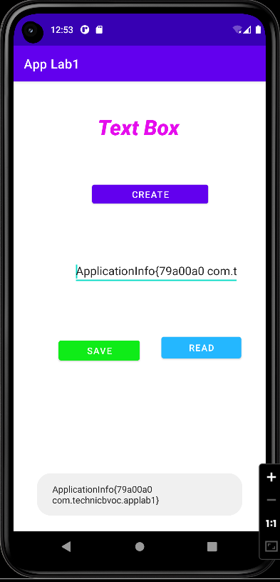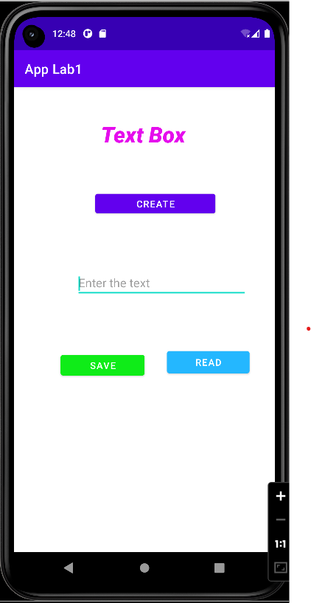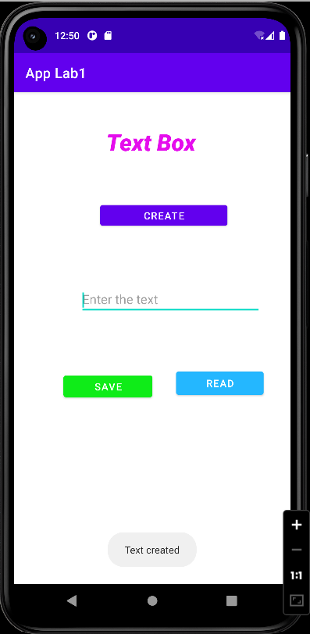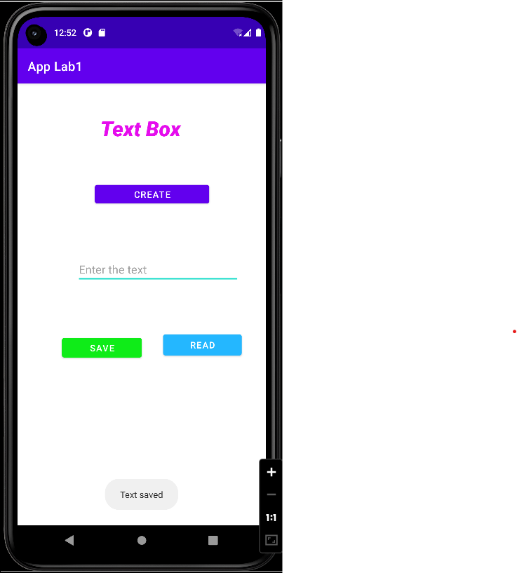

**12. Create an application to demonstrate a basic media player that allows the user to Forward, Backward, Play and Pause an audio. Also, make use of the indicator in the seek bar to move the audio forward or backward as required.**

**SOURCE CODE**

**XML CODE : activity_main.xml**

**JAVA CODE - MainActivity.java**

**13. Develop an application that makes use of the clipboard framework for copying and pasting of the text. The activity consists of two EditText controls and two Buttons to trigger the copy and paste functionality.**

**SOURCE CODE**

**XML CODE : activity_main.xml**

<?xml version="1.0" encoding="utf-8"?>

<RelativeLayout xmlns:android="http://schemas.android.com/apk/res/android"

xmlns:app="http://schemas.android.com/apk/res-auto"

xmlns:tools="http://schemas.android.com/tools"

android:layout_width="match_parent"

android:layout_height="match_parent"

android:background="#00000000"

android:backgroundTintMode="multiply"

android:foregroundTint="#404040"

android:textAlignment="center"

tools:context=".Clipboard">

<TextView

android:id="@+id/textView19"

android:layout_width="230dp"

android:layout_height="70dp"

android:layout_alignParentStart="true"

android:layout_alignParentTop="true"

android:layout_alignParentEnd="true"

android:layout_alignParentBottom="true"

android:layout_centerHorizontal="true"

android:layout_marginStart="113dp"

android:layout_marginTop="80dp"

android:layout_marginEnd="68dp"

android:layout_marginBottom="581dp"

android:backgroundTint="#FADFB80E"

android:fontFamily="serif"

android:text="ClipBoard"

android:textAllCaps="false"

android:textColor="#E30606"

android:textColorHighlight="#6A4949"

android:textSize="36dp"

android:textStyle="bold|italic" />

<EditText

android:id="@+id/editTextTextPersonName8"

android:layout_width="292dp"

android:layout_height="63dp"

android:layout_alignParentStart="true"

android:layout_alignParentTop="true"

android:layout_alignParentEnd="true"

android:layout_alignParentBottom="true"

android:layout_centerHorizontal="true"

android:layout_marginStart="61dp"

android:layout_marginTop="216dp"

android:layout_marginEnd="58dp"

android:layout_marginBottom="452dp"

android:ems="10"

android:hint="enter the text"

android:inputType="textPersonName" />

<EditText

android:id="@+id/editTextTextPersonName9"

android:layout_width="wrap_content"

android:layout_height="73dp"

android:layout_alignParentStart="true"

android:layout_alignParentTop="true"

android:layout_alignParentEnd="true"

android:layout_alignParentBottom="true"

android:layout_centerHorizontal="true"

android:layout_marginStart="64dp"

android:layout_marginTop="324dp"

android:layout_marginEnd="59dp"

android:layout_marginBottom="334dp"

android:ems="10"

android:hint="paste "

android:inputType="textPersonName" />

<Button

android:id="@+id/button14"

android:layout_width="118dp"

android:layout_height="wrap_content"

android:layout_alignParentStart="true"

android:layout_alignParentTop="true"

android:layout_alignParentEnd="true"

android:layout_alignParentBottom="true"

android:layout_marginStart="65dp"

android:layout_marginTop="474dp"

android:layout_marginEnd="228dp"

android:layout_marginBottom="195dp"

android:text="Copy" />

<Button

android:id="@+id/button15"

android:layout_width="wrap_content"

android:layout_height="wrap_content"

android:layout_alignParentStart="true"

android:layout_alignParentTop="true"

android:layout_alignParentEnd="true"

android:layout_alignParentBottom="true"

android:layout_marginStart="232dp"

android:layout_marginTop="476dp"

android:layout_marginEnd="57dp"

android:layout_marginBottom="195dp"

android:text="paste" />

</RelativeLayout>

**JAVA CODE - MainActivity.java**

package com.technicbvoc.applab1;

import androidx.appcompat.app.AppCompatActivity;

import android.content.ClipData;

import android.content.ClipboardManager;

import android.os.Bundle;

import android.view.View;

import android.widget.Button;

import android.widget.EditText;

import android.widget.Toast;

public class Clipboard extends AppCompatActivity {

EditText ed1,ed2;

Button b1,b2;

private ClipboardManager myClipboard;

private ClipData myClip;

@Override

protected void onCreate(Bundle savedInstanceState) {

super.onCreate(savedInstanceState);

setContentView(R.layout.activity_clipboard);

b1=(Button) findViewById(R.id.button14);

b2=(Button) findViewById(R.id.button15);

ed1=(EditText) findViewById(R.id.editTextTextPersonName8);

ed2=(EditText) findViewById(R.id.editTextTextPersonName9);

myClipboard=(ClipboardManager) getSystemService(CLIPBOARD_SERVICE);

b1.setOnClickListener(new View.OnClickListener() {

@Override

public void onClick(View v) {

String text;

text=ed1.getText().toString();

myClip=ClipData.newPlainText("Text",text);

myClipboard.setPrimaryClip(myClip);

Toast.makeText(getApplicationContext(),"Text Copied",Toast.LENGTH_SHORT).show();

}

});

b2.setOnClickListener(new View.OnClickListener() {

@Override

public void onClick(View v) {

ClipData abc=myClipboard.getPrimaryClip();

ClipData.Item item=abc.getItemAt(0);

String text=item.getText().toString();

ed2.setText(text);

Toast.makeText(getApplicationContext(),"Text Pasted",Toast.LENGTH_SHORT).show();

}

});

}

}

**Output:**

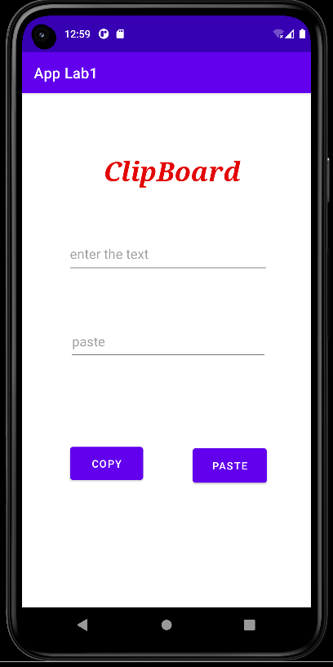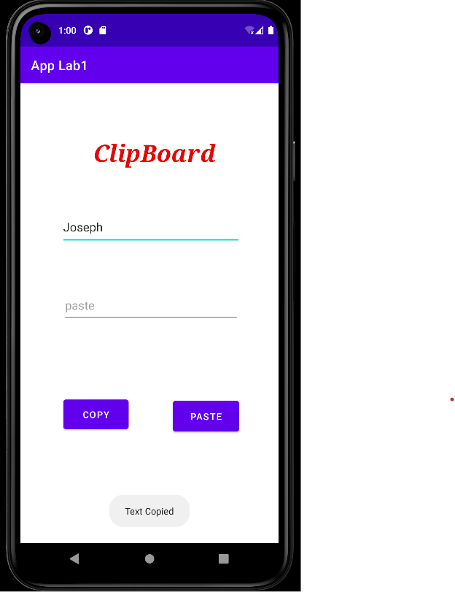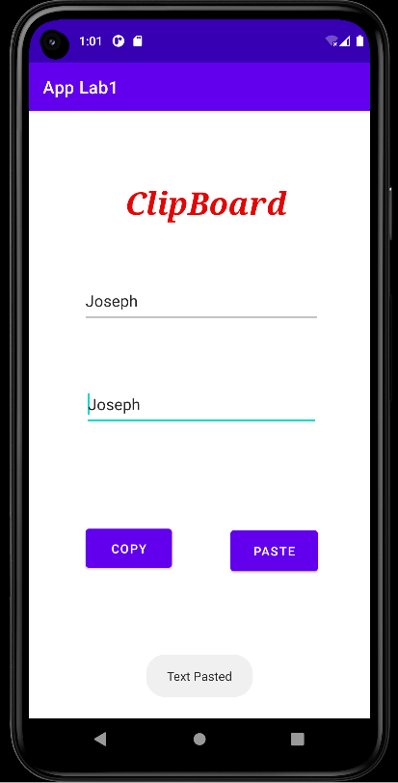

**14. Create an AIDL service that calculates Car Loan EMI. The formula to calculate EMI is E = P * (r(1+r)n )/((1+r)n -1)**

**where E = The EMI payable on the car loan amount**

**P = The Car loan Principal Amount**

**r = The interest rate value computed on a monthly basis**

**n = The loan tenure in the form of months.**

**The down payment amount has to be deducted from the principal amount paid towards buying the Car. Develop an application that makes use of this AIDL service to calculate the EMI. This application should have four EditText to read the Principal Amount, Down Payment, Interest Rate, Loan Term (in months) and a button named as “Calculate Monthly EMI”. On click of this button, the result should be shown in a TextView. Also, calculate the EMI by varying the Loan Term and Interest Rate values.**

**SOURCE CODE**

**XML CODE : activity_main.xml**

**JAVA CODE - MainActivity.java**